WHONET Manual

GLOBAL ANTIMICROBIAL RESISTANCE SURVEILLANCE SYSTEM – EGASP

John Stelling

Brigham and Women’s Hospital

WHO Collaborating Centre for Surveillance

of Antimicrobial Resistance

Boston, Massachusetts

July 2024

**Abbreviations**

AMR Antimicrobial Resistance

CLSI Clinical and Laboratory Standards Institute

EUCAST European Committee on Antimicrobial Susceptibility Testing

GLASS Global Antimicrobial Resistance Surveillance System

EGASP Enhanced Gonococcal Antimicrobial Surveillance Programme

ID Identifier

MIC Minimum inhibitory concentration

WHO World Health Organization

**Table of Contents**

1. Introduction 1

2. Installing WHONET 2

3. Laboratory configuration 3

3.1 Creating a new laboratory configuration 3

3.2 Copying an existing laboratory configuration 6

3.3 Modifying laboratory configuration 7

4. WHONET data entry for EGASP 9

4.1 General 9

4.2 View database 10

5. Data collection at the national level 11

6. Exporting WHONET files to the EGASP exchange format 11

6.1 Combining WHONET files 12

6.2 Downloading the data export template from the EGASP IT platform 12

6.3 Aggregation of WHONET files 15

7. EGASP Data Monitoring and Feedback Report 18

8. Upload the EGASP-formatted data file to the EGASP IT platform 19

Annex 1 – Modify laboratory configuration 20

1. General laboratory information 20

2. Antibiotics 21

3. Antibiotic breakpoints 22

4. Locations 24

5. Modifying data field configuration 24

Annex 2 – BacLink introduction 26

# Introduction

This manual is written primarily for national EGASP data managers. It can also be used by data managers at laboratories serving surveillance sites participating in EGASP. It describes how to use WHONET in handling data for EGASP. WHONET supports output of data to GLASS exchange format for uploading to the GLASS IT platform. This is not the complete WHONET manual describing all its functionalities and features. The complete WHONET manual (including BacLink tutorials) can be downloaded from the WHONET home page at [www.whonet.org](http://www.whonet.org).

WHONET supports participation in GLASS as:

* it is freeware, downloadable from the WHONET Home Page, [www.whonet.org](http://www.whonet.org); and
* it supports output to the EGASP data exchange format.

WHONET includes Data Check Feedback Reports, e.g.

* it gives **direct feedback** on microbiological aspects for **the isolate level** (e. g. alert on Methicillin-resistant *Staphylococcus aureus*; Penicillin non-susceptible *Streptococcus pneumoniae* to allow possible interventions on site; and
* it **checks GLASS aggregated data validity** and **completeness**, producing feedback reports indicating if it is necessary to correct data or make them complete before uploading to the GLASS IT platform.

Section 2: “Installing WHONET” is intended for national and local users of the WHONET software.

Section 3: “Laboratory configuration” and Section 4: “WHONET data entry for GLASS” are intended for users who will enter data into WHONET. Data entry can be accomplished at the national level by technical staff of the network coordinating institution who receives data submitted on paper forms from participating facilities. In the case of data entry into WHONET at the level of participating facilities, electronic WHONET data files are sent to the national level; at the national level WHONET data files from different facilities are combined and aggregated to the GLASS exchange format.

Note: If participating facilities already have laboratory information systems or susceptibility test instruments with the desired surveillance data, it is usually possible to avoid manual data entry using BacLink – WHONET’s data import module – to capture and standardize data from existing information resources. Further information about BacLink is provided as an Annex in this manual and can also be found in the BacLink tutorial *BacLink 1 – Getting started* which is available from http://www.whonet.org/documentation.html.

Sections 5 through 8 are intended for use by national surveillance system coordinators responsible for collation, analysis, validation and submission of surveillance data to the GLASS IT platform.

For comments and questions on WHONET use, please write to [help@whonet.org](mailto:help@whonet.org).

# Installing WHONET

The software is available from the WHONET Home Page at [WHONET.org](http://whonet.org/). Click on “Software” and download WHONET 2024 (Desktop version), or the most recent version available.

WHONET requires a computer running Microsoft Windows versions 8.1 or later, and also requires that Windows .NET version 4.8 is installed. After downloading the software, double-click on the downloaded file and follow the instructions on the screen (“Run”, “OK”, etc.). If you receive a message about “insufficient administrative rights” to install the software, you will need to contact your facility’s system administrator to install the software for you or to grant you the necessary local administration rights temporarily.

The default location for the WHONET installation is C:\WHONET\. You may change this as you wish. For example, if you would like to use WHONET on a network drive to permit shared use by multiple staff members, you can install the software to a common drive such as T:\WHONET\.

In case you already have an older version of WHONET (prior to “WHONET 2016”) on your PC, then you may install the updated WHONET applications side by side in different folders and copy your data and configuration files to the new folders. This method will retain your ability to use the older version of the software. Alternatively, you can use the browse feature to locate the configuration files without copying them.

After installing the programme, you will find the WHONET and BacLink icons on your computer’s desktop.

Note: If you have an antivirus, or system protection software installed such as Microsoft SmartScreen, Norton Antivirus, Symantec Antivirus, etc., it is possible that you may encounter a warning message similar to the following:



This message appears because the software is new and has not been installed on many systems, so the antivirus software notifies you that you should take extra precaution. It does not indicate a problem with the installation package. To proceed, you must follow your system’s prompts to continue with the installation. It may be necessary to open your computer’s downloads folder in order to locate the installation package.

Additionally, you may wish to scan the file using your antivirus software before installing the application. You should also verify that the installer is from the verified publisher “Brigham and Women’s Hospital.” This last point ensures that the installation package is authentic and has not been modified since it was created.

# Laboratory configuration

## 3.1 Creating a new laboratory configuration

To configure an EGASP laboratory:

* Start WHONET, the screen below appears, click “Cancel”

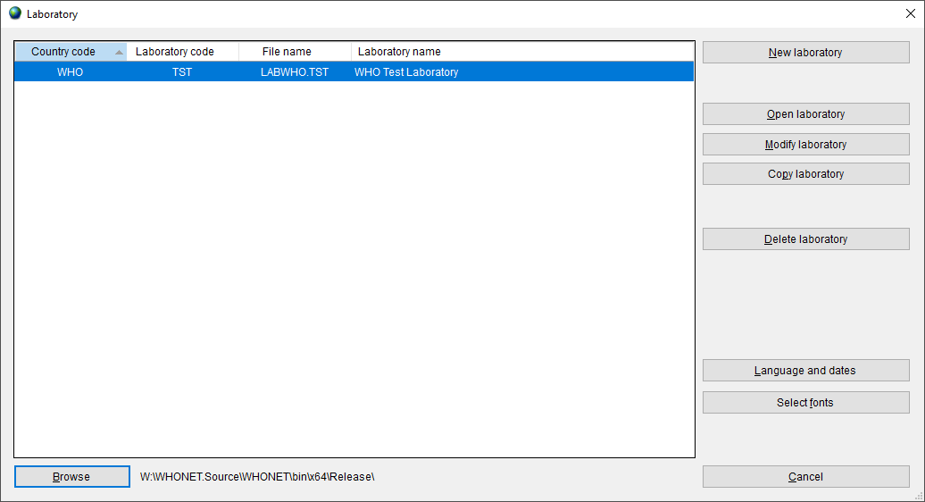

Then the main WHONET screen appears.

* Click “File”, select “WHO GLASS-EGASP“ and click “New laboratory”. 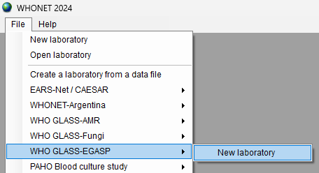
* The following screen appears requesting that you answer some basic information about the new laboratory configuration you are about to create.

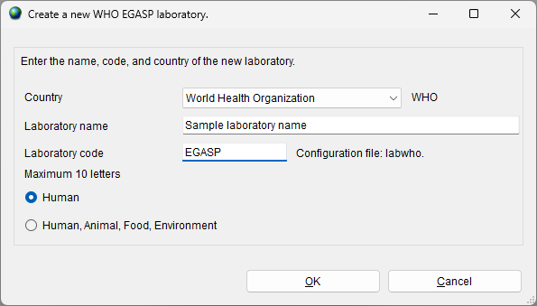

* Indicate your country, laboratory name and laboratory code, then click “OK”.
* The screen below appears. Select the guidelines used at the laboratory and click “OK”.

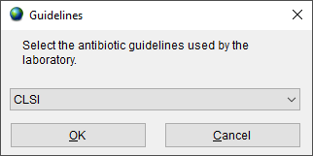

With the EGASP configuration WHONET will create a new laboratory with the recommended set of antibiotics, data fields and codes. You will then be prompted with the following screen.

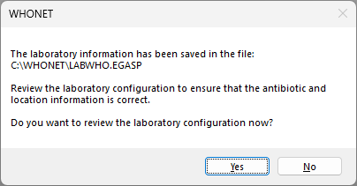

* If you want to review the configuration and make any additional modifications, select “Yes” and follow instructions in section 3.3 and Annex 1. Otherwise, select “No” to proceed directly with WHONET data entry and analysis.

Before you start with data entry, we recommend that you review to check if it is necessary to make changes to the antibiotic interpretative breakpoints. For details of how to make any additional changes please refer to section 3.3 and Annex 1.

## 3.2 Copying an existing laboratory configuration

If the national data manager is responsible for working with multiple facilities, the “Copy laboratory” feature can be used to clone the created EGASP laboratory to new ones, assigning a new name and code to each additional facility created. This is described in further detail below.

* Choose from main menu, “File”, “Open laboratory”.
* To copy an existing laboratory configuration e.g. LABWHO.EGASP, select LABWHO.EGASP from the screen below, and click on “Copy laboratory”.

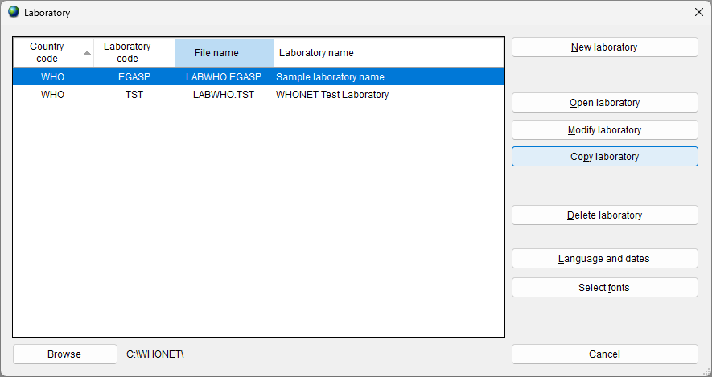

The screen below will appear:

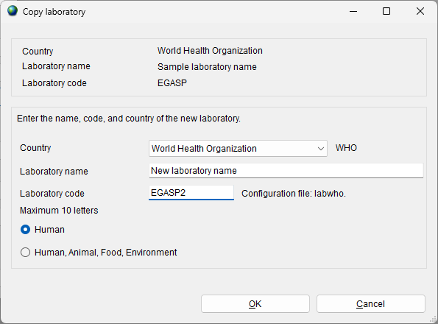

* Enter the country, laboratory name and laboratory code (numbers) and click “OK”.

## 3.3 Modifying laboratory configuration

When using the feature “Create a new WHO GLASS-EGASP laboratory”, WHONET defines a laboratory configuration with a list of antibiotics and data fields. However, the data manager may wish to further customize the configuration to more closely match data entry, analysis and reporting needs on site and at the national level.

Options include:

* **General information:** The user may modify the laboratory code, full laboratory name and country code. The user can also specify whether isolates of human origin will be collected primarily or whether human, animal, food and/or environmental isolates are to be collected in one database.
* **Data fields:** When the “Create a new WHO GLASS-EGASP laboratory” feature was used, WHONET created a list of data fields, such as “Identification number”, “Specimen type” and “Organism”. The user may add or remove data fields from this list to more closely match data management preferences, for example “Patient last name” or “Date of birth”.
* **Locations:** A list of patient care areas may be created for the laboratory configuration e.g. “Emergency Room”, “General medical ward” and “Surgical intensive care unit”. This will be particularly useful if the user plans to use WHONET for purposes of clinical reporting or data analysis on site. If data for this variable are to be combined at the national level with data from different facilities, a standardized list of patient care areas must be implemented by the coordinating centre.
* **Antibiotics:** Antibiotics may be added or removed from the antibiotic list established for the laboratory configuration so that it more closely matches the set of antibiotics tested on site or considered under surveillance at the national level. “Antibiotic panels” may be defined, which control the organism-specific list of antibiotics displayed to the user during data entry or “antibiotic profiles” used in the WHONET data analysis module. The breakpoints automatically defined by WHONET can be reviewed and edited in this module.

Further details on these configuration features can be found in Annex 1.

# WHONET data entry for EGASP

## General

Before starting “Data entry” the user should open the corresponding laboratory configuration.

* Click on main menu, “File”, “Open laboratory”. Select laboratory and click on “Open laboratory”.

WHONET uses the data structure defined in the current laboratory configuration and will use the breakpoints as defined in the laboratory configuration.

* Select a new data file or open an existing file. To make a new file, select “Data Entry” from the menu bar and then select “New Data File”.

The screen Data entry (below) appears.

* Enter the name of the file to be created, for example “WHO-EGASP-2024.sqlite”

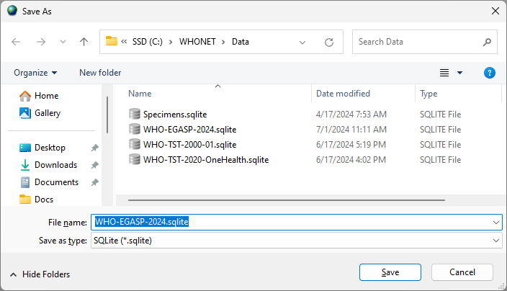

By default, data files are stored in the C:\WHONET\Data\ folder, but the user may use the “Drives” and “Folder” boxes to specify a preferred data file location.

* Click OK to proceed with data entry.

Once a data file has been opened or created, the “Data entry” screen (below) will appear. Data are entered in the fields on the left half of the screen.

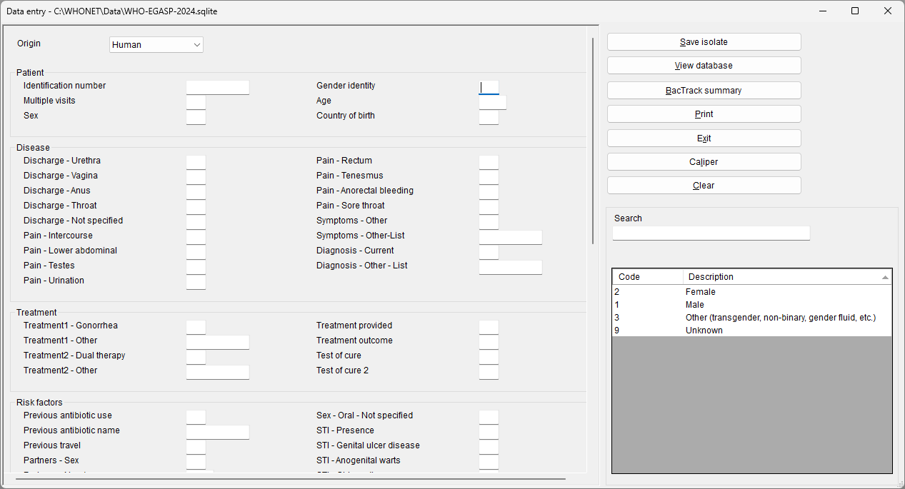

General explanation for data entry:

When the cursor jumps to a field for data entry, brief instructions and recommended data codes for that field appear at the lower right of the screen.

After entering data in one field, there are four ways of moving to the next field:

* press the <Enter> key; or
* press the <Tab> key; or
* press the arrow keys; or
* use the mouse.

Enter **dates** in the same format as the default format on the computer in use, namely as day/month/year or month/day/year or year/month/day. After entering a date and moving to the next field, the user should check that the date has been interpreted correctly – WHONET automatically converts the numeric month to the name of the month. When entering a date, the year can be entered as a 2- or 4-digit date. The numbers indicating day, month and year must be separated by a /, hyphen, or space.

## View database

* From menu choose, “Data entry”, “Open data file”, select data file and click on “Open”.
* To check the records once data entry has been performed, click on “View database”: the screen below appears.
* To make changes, select the record to be changed and click “Edit isolate.” The data entry screen will appear again and changes can be entered. Click “Save isolate” to save these changes.

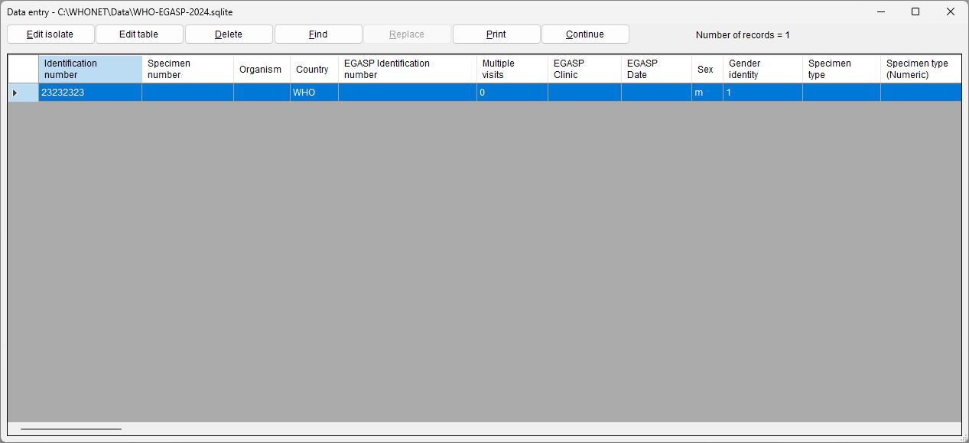

* To leave the screen above, click on “Continue” and “Exit”.

# Data collection at the national level

The previous sections covered the entry of data into WHONET. This can be accomplished by staff at each of the surveillance sites participating in the national surveillance system or alternatively at the national level by the surveillance system coordinators utilizing paper forms or electronic records received from participating facilities.

If data entry is accomplished by the participating facilities, then data entry staff should periodically send their WHONET data files securely to the national programme coordinators.

If facilities already have electronic data stores, for example in a laboratory information system or a laboratory organism and identification susceptibility test instrument, then BacLink – WHONET’s data import module – can usually be utilized to import the data into WHONET. Further details are available in the BacLink tutorials, starting with *BacLink 1 – Getting started* which is available from <https://whonet.org/training.html>*.* BacLink can be run at the local level directly by facility staff members. Alternatively, national network coordinators can receive raw data files from participating facilities and convert these into WHONET files using BacLink at the national level, as introduced in Annex 2 and described further in a series of BacLink tutorials.

# Exporting WHONET files to the EGASP exchange format

There are 2 scenarios for WHONET files:

* Data have been entered manually at the national level following the instructions provided in the previous sections; or
* electronic files in WHONET format have been received from participating surveillance sites.

**Manual data entry**

After manual data entry the files are saved in WHONET format. Before uploading them to the EGASP user interface, they must be exported to the EGASP data exchange format. It is possible that the user may have national WHONET data stored in a single large WHONET file, or alternatively, the user may have separate WHONET files representing various facilities, specimens and time periods. If multiple files exist, the user may first wish to combine them together into a single large WHONET file using the procedure described below (section 6.1).

**Electronic data entry**

After receiving electronic WHONET data files from participating surveillance sites the user may first want to combine data files from more than one surveillance site into a single large WHONET file. However, surveillance sites may use different WHONET software versions and different laboratory configurations. If the laboratories are testing exactly the same antibiotics with the same set of breakpoints, the data files can be combined using any one of the corresponding laboratory configurations. On the other hand, if the laboratories are testing different antibiotics or using different breakpoints, then a new “national” laboratory configuration should be created and customized that includes a list of all antibiotics tested (with the corresponding breakpoints), as mentioned earlier in Sections 3.1 and 3.3.

## Combining WHONET files

We first describe how to combine WHONET files from different surveillance sites into one single large WHONET file before aggregation of data.

* To combine data files in a preferred configuration, select “Open laboratory” and choose the laboratory with the corresponding configuration.
* Click on “Data entry” from the main WHONET screen. Choose “Combine or export data files”. Indicate the data files that are to be combined and enter the name of the new data file being created. The default option “Save as type” is WHONET.
* Then click on “Combine”.
* When WHONET finishes, the original data files will be unchanged, but the user will now have a new large data file that includes all the results from the original files. The new WHONET data file is stored per default in the C:\WHONET\Data folder.

## Downloading the data export template from the EGASP IT platform

The WHO-EGASP 2.0 platform only accepts data in a specific format. To export data to the web IT platform, you must first log in to the platform and download the template Excel file. WHONET will transfer data into this template as described in the next section.

* Log in to the WHO-EGASP platform.
* From the main menu, choose “Data Submissions History”

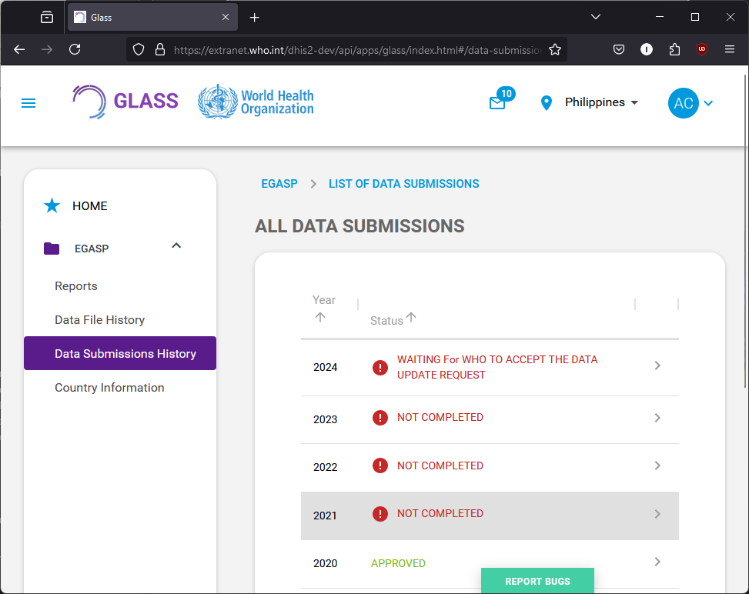

* Select a row on the right corresponding to the data year you would like to submit.
* Select the “Datasets” tab, and press “Add new datasets”.

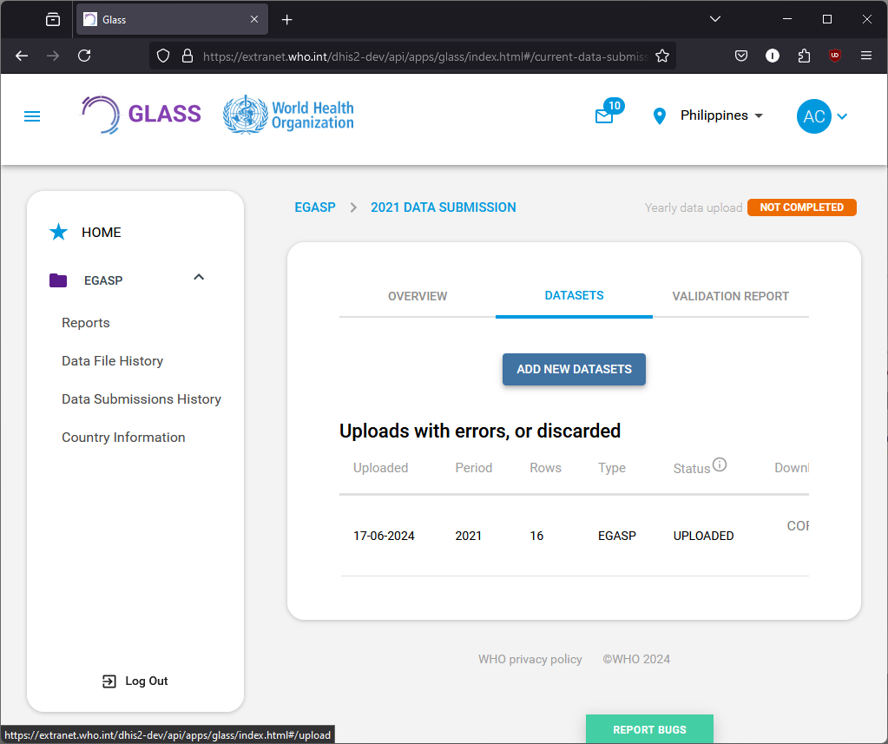

* On the following screen, press the button to “Download empty template”.

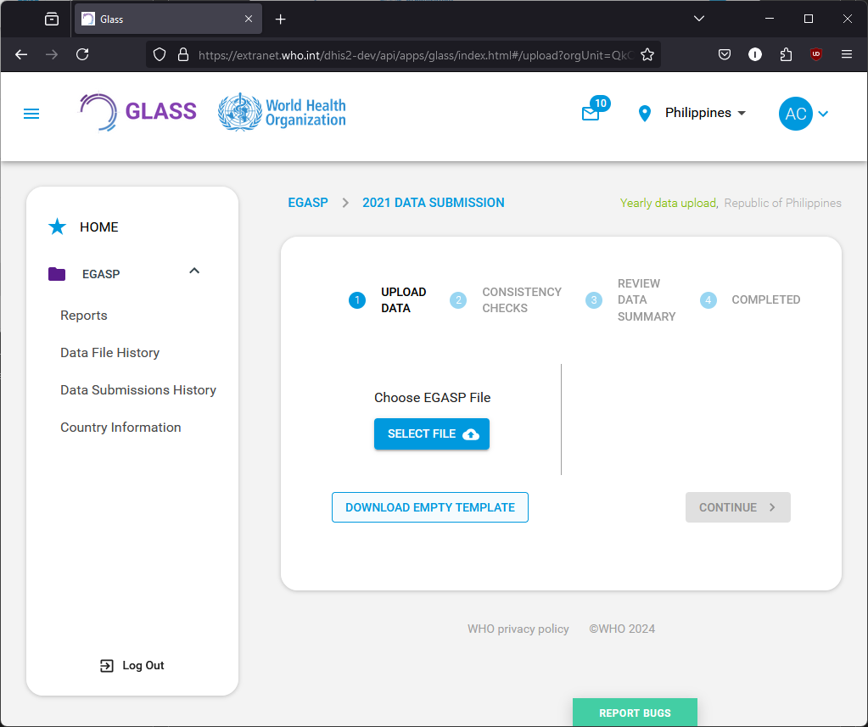

* By default, the Excel file will be saved to your computer’s designated “Downloads” folder. You may wish to move the file to the C:\WHONET\Data\ folder. Please note the location of the file in either case so that you can easily find it for the next section.

## Aggregation of WHONET files

The next steps describe the aggregation of one or several data files directly into the EGASP exchange format. The created data will be transferred to the “empty download template” file obtained in the previous section.

* From the main WHONET menu, again select “Open laboratory” and choose the laboratory with the corresponding configuration created previously.
* From the main WHONET menu, select “Data entry”, “Combine or export data files”.

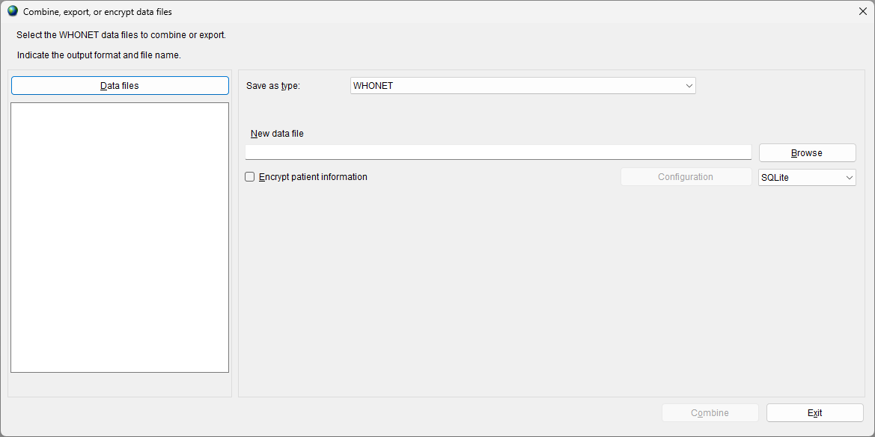

* Click on “Data files”.

The next screen will appear (example file is displayed): 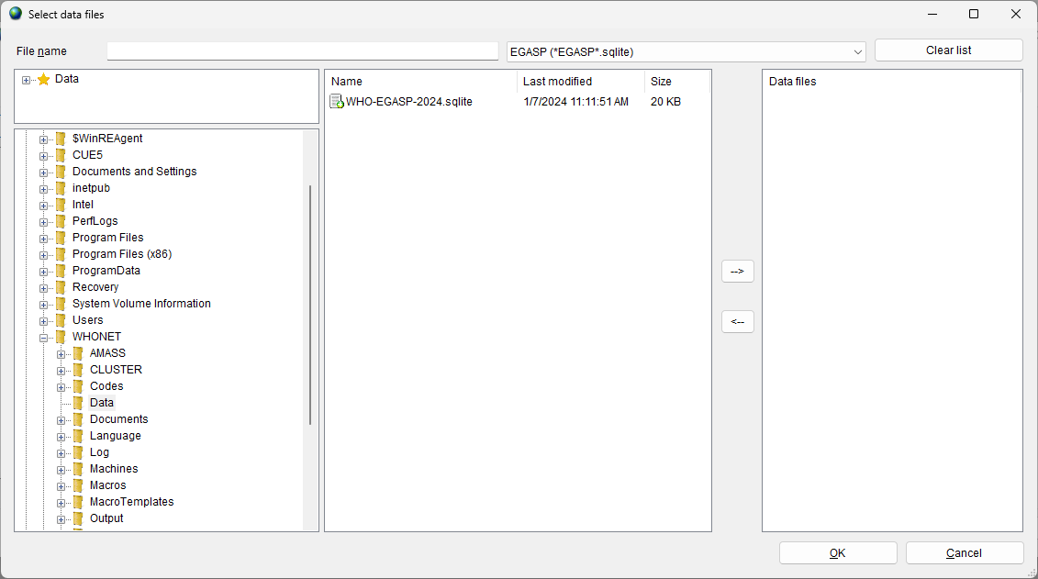

* Choose “All files (*.*)” to get a list of all files.
* Using the “-->” button, select the data files to be exported to the EGASP data exchange format.
* Click “OK”. You will return to the previous screen.
* Indicate a name for the new combined, export file*.*
* Under “Save as type”, change the export format from “WHONET” to “WHO GLASS-EGASP”.
* Enter the start and end date for the data which you wish to include in this export.
* Press the “Browse” button associated with the “New data file” area.
* Use the file selection dialog to choose the empty template file downloaded previously from the EGASP IT platform.

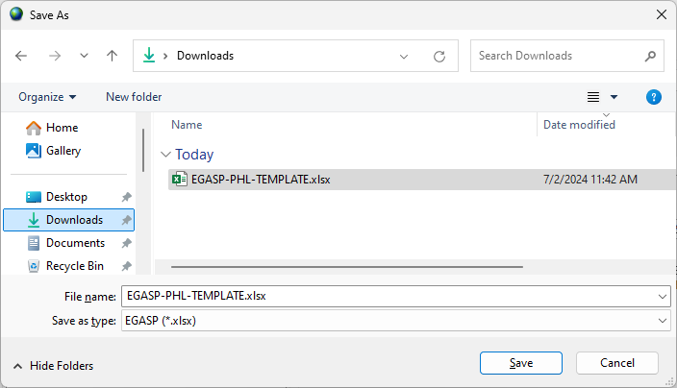

* Press “Combine” near the bottom of the form.

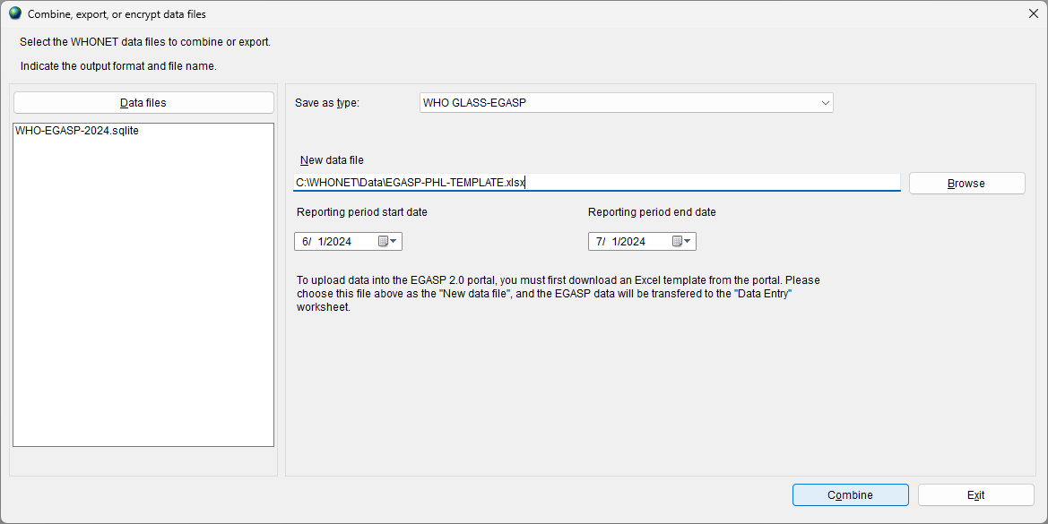

WHONET will generate 2 files:

* The EGASP data will be saved to the empty template file’s “Data entry” sheet.
* The EGASP data monitoring Excel report. Note that it may take a few minutes to generate this document, so please be patient.

Only the first file should be uploaded to the EGASP IT platform.

# EGASP Data Monitoring and Feedback Report

* After completion of the data files export, the following screen will appear:

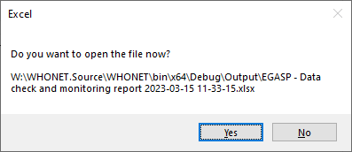

* By clicking on “Yes”, the following EGASP report will be opened in Excel for you to review.

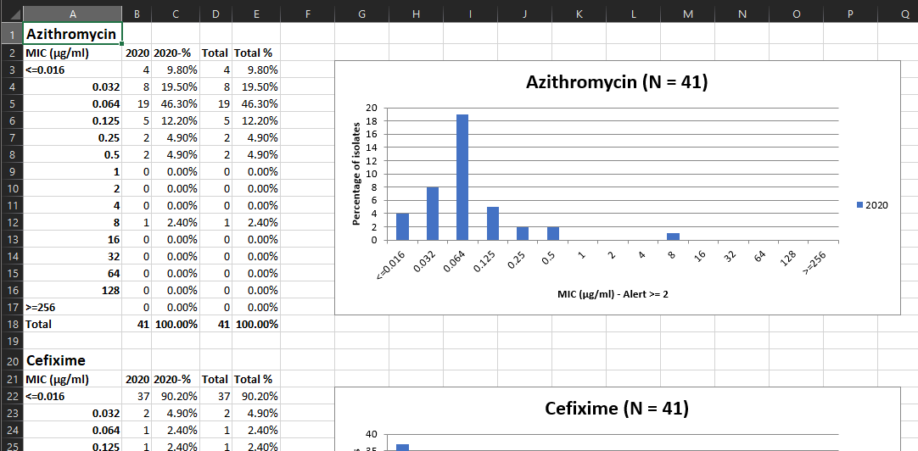

* There are up to 8 Excel sheets in this report.
  + Validation summary
    - This sheet will only be present if there were validity issues detected with the values in your data file. For example, if the letter “x” was entered instead of the expected value “1” or “2”.
  + Validation details
    - This sheet will provide a detailed view of the messages summarized in the first sheet. It will only be present if validity issues were detected.
  + Consistency summary
    - This sheet will only be present if there were consistency issues detected with the responses you provided in the data file. For example, if you indicated that retesting was done on the isolate, but we don’t have confirmatory test results for that isolate.
  + Consistency details
    - This sheet provides a detailed view of the messages summarized in the consistency summary. It will only be present if consistency issues were detected.
    - Both the validation and consistency details sheets provide identifying information which you can use to look up and correct the problems in the WHONET data file.
  + Indicators
    - This sheet provides a range of different important statistics relevant for reporting. Please review it carefully to ensure that it matches your expectations.
  + Descriptive statistics
    - This sheet provides a range of descriptive statistics breaking down the data in your data file. Please also review this carefully to spot issues you may have missed with your data.
  + Cumulative distribution
    - This sheet provides a cumulative MIC distribution and associated graphs for each antibiotic.
  + Aggregated distribution
    - This sheet provides the same information as the cumulative view, but it is additionally stratified by year.

If any errors or unexpected findings are noted during the validation process, the user should review the original data files, edit if warranted, and then re-export the data.

# Upload the EGASP-formatted data file to the EGASP IT platform

When data is exported using the steps described above, WHONET will update an empty template with your data to be exported to the online platform. EGASP instructions for uploading the file to the EGASP IT platform are available.

# Annex 1 – Modify laboratory configuration

This annex provides further explanations on the WHONET module for modifying the laboratory configuration for antibiotics, locations and data fields. For more detailed information, please consult the relevant WHONET tutorials, available from http://whonet.org/documentation.html.

## General laboratory information

Step 1: Collect information on antibiotics, test methods and breakpoints specific to the participating laboratory.

Step 2: Start WHONET by double-clicking on the WHONET icon. When the user enters “New Laboratory”, the “Laboratory configuration” screen appears.

This screen will also appear after the user has created a new EGASP laboratory following the steps in section 3.1. At the end of this process the user will be asked whether any additional modifications are required: select “Yes”.

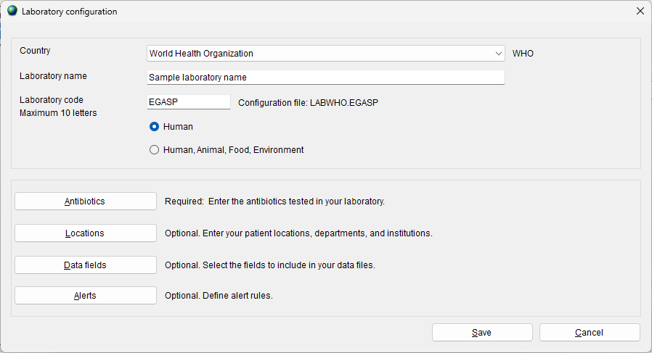

Step 3: Describe *Laboratory (*Required): Choose the country and enter the name of the laboratory. Enter a three-letter laboratory code.

Note: After entering this information WHONET will automatically create a corresponding laboratory configuration file name with the name labccc.xxx, where ccc = 3-letter ISO country code and xxx = 3 characters of laboratory code.

Step 4: *Antibiotic Configuration* (Required): Click on “Antibiotics” to configure the antibiotics. Enter the list of antibiotics that are being used by the laboratory. Click “OK” when finished to return to the main “Laboratory configuration” screen. For details see section 2 below: “Antibiotics”.

## Antibiotics

To indicate which antibiotics, methods and breakpoints are being used in the participating laboratory the user must enter “Antibiotic configuration”.

Note: During data entry the software performs automatic interpretation based on the breakpoints entered in this configuration.

Instructions

Step 1: From the main Laboratory Configuration screen, click on “Antibiotics”: the screen below appears. The “WHONET antibiotic list” appears on the left, while the antibiotics that the user may want to select will appear on the right under “Local antibiotic list”. The list on the right will already contain GLASS antibiotics if the user has chosen the GLASS laboratory configuration.

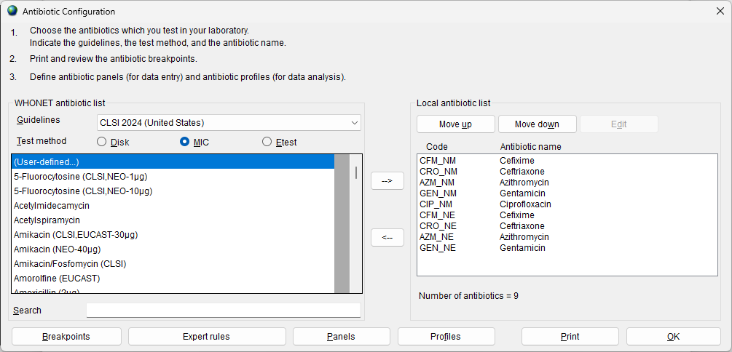

Step 2: For each combination of antibiotic, method and testing guidelines:

* Select the correct testing guidelines (CLSI, EUCAST, *etc.*); and
* click on the correct test method (disk diffusion, MIC, ETest®); and
* select the correct antibiotic (and disk potency for disk diffusion testing).

An antibiotic can be selected by double-clicking on it or, alternatively, by clicking on it once and then clicking the right arrow button “-->”.

Once all the antibiotics have been entered, review the list and make any needed corrections. To remove an antibiotic from the local antibiotic list, double-click on the antibiotic or single-click on the antibiotic and hit the left arrow button “<--“. The sequence of the antibiotics may be changed using the “Move up” and “Move down” buttons.

Note: Each antibiotic test is given a code (up to nine letters) consisting of: the three-letter antibiotic code, a one-letter code indicating the guideline reference (e.g. N=CLSI, formerly NCCLS, E=EUCAST), a one-letter code indicating the test method (D=disk diffusion, M=MIC, E=ETest®), and a disk potency for drugs tested by disk diffusion. For MIC or ETest® it is only necessary to select the correct antibiotic and correct guideline – the disk potency indicated is not relevant. For example, the code GEN_ND10 represents: gentamicin, CLSI (NCCLS), disk diffusion, 10 µg, while GEN_EM is: gentamicin, EUCAST, MIC.

Step 3: When satisfied with the list, the user can choose from the following options:

* “OK” to return to main “Laboratory configuration” screen. Note the information has to be saved by clicking on “Save” in the main “Laboratory configuration” screen.
* “Panels” and “Profiles” are optional: to facilitate data entry, the user may wish to use “Panels” to indicate which antibiotics are tested for each kind of organism. For details refer to the complete WHONET manual.
* “Print”: obtain a printout of the antibiotics and their breakpoints. It is recommended that breakpoints are printed for review and reference before data entry commences.
* “Breakpoints”: to review, modify and update the antibiotic breakpoints. See next section 3 “Antibiotic breakpoints”.

## Antibiotic breakpoints

WHONET will automatically load the most recent breakpoints for the antibiotics that have been indicated. Although not recommended for most users, it may happen that a laboratory uses other breakpoints then standard reference breakpoints, and for these situations it is possible to edit the WHONET-provided standard breakpoints.

Instructions

Step 1: From the “Antibiotic configuration” screen, click on “Breakpoints”. The following screen will appear.

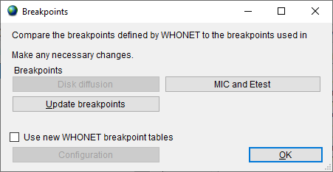

Step 2: The following options are available:

* “Species-specific”: review and edit the list of species-specific disk diffusion or MIC breakpoints. For details, see Step 3a.

“Update breakpoints”: The WHONET antibiotic definition files are updated annually as new recommendations from the reference authorities become available. If the user downloads WHONET on an annual basis, the download will include the new breakpoints. WHONET will not automatically use these new breakpoints for an existing antibiotic list until the user clicks on “Update breakpoints” to replace the breakpoints that have been set for the laboratory with the antibiotic breakpoints to be found in the most recent antibiotic definition files.

“OK”: When finished reviewing or modifying the antibiotic breakpoints, selecting “OK” will return the user to the “Antibiotic configuration” screen.

**This example illustrates the procedure:**

Step 3A

*Editing Species-Specific Antibiotic Breakpoints:* A screen similar to the one below will appear. In most countries, changes to these WHONET-provided reference breakpoints are not required. However, if the user wishes to make modifications to the breakpoints, changes to the table breakpoints below may be made using the same procedure as described in Step 3a.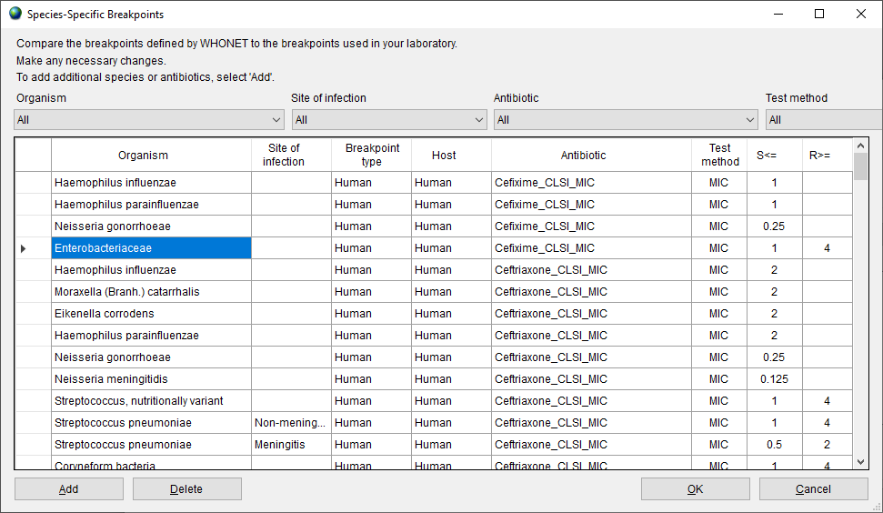

*Adding Species-Specific Antibiotic Breakpoints*: If it is necessary to enter additional species-specific breakpoints, select “Add”, and the screen below will appear. Indicate the organism-antibiotic combination for which one wants to define breakpoints by clicking on the desired organism and the desired antibiotic. When finished, select “OK” to return to the previous screen where the breakpoints may be entered.

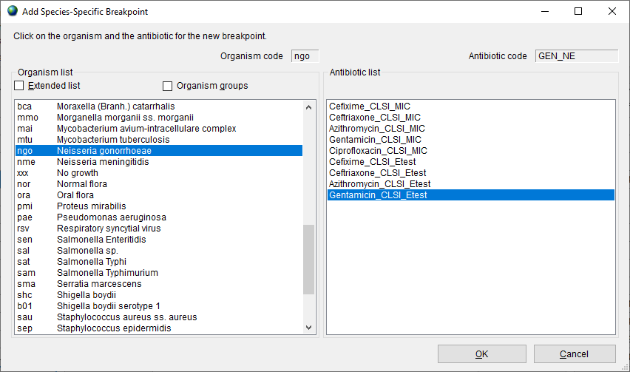

*Deleting Species-Specific Antibiotic Breakpoints:* To delete a species-specific breakpoint, click on the relevant row of the table, and click ‘Delete’.

After completing changes to the breakpoints, select “OK” to return to the “Antibiotic Breakpoint” screen. Select “OK” again to return to the “Antibiotic Configuration” screen.

## Locations

This option from the main screen “Laboratory configuration” is optional, but is of value if the user would like to keep track of patient locations and medical services from which samples are taken. A detailed description is found in the main WHONET manual.

## Modifying data field configuration

A set of “standard” data fields is defined automatically by WHONET. “Standard” fields include routine information such as: unique patient ID, location type, specimen date, specimen type, organism/pathogen, antibiotic panel, etc. To combine additional surveillance activities with the EGASP data collection, the user may want to add some “additional” data fields: see instructions below.

Instructions

Step 1: From the main “Laboratory configuration” screen, select “Data fields” and click on “Modify list”. A screen similar to the one below should appear. The lists of WHONET data categories (clinical, infection control, etc.) and data fields (diagnosis, admission date, etc.) from which the user may select appear on the left. If the user selects “EGASP”, this will show the EGASP data fields in the box “Data fields”. Select all and click the right arrow. They will be added to the list of data fields that appear to the right (also containing the standard data fields).

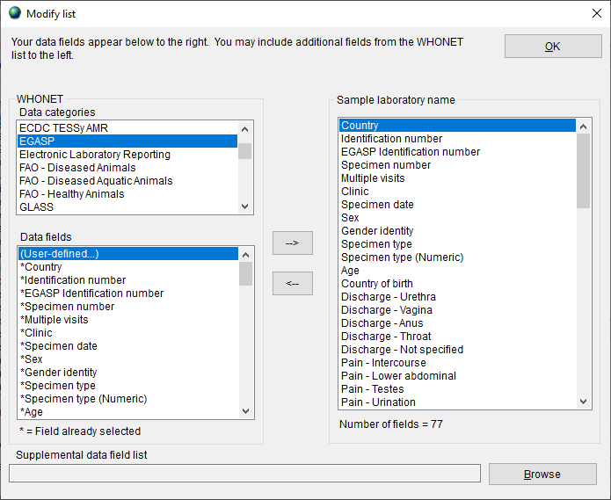

Step 2: If the user would like to include more additional fields in their data files, then they may be selected here also.

Note: By default, WHONET will check the validity of EGASP codes entered during data entry.

Step 3: Leave this screen by clicking on “OK” twice and click on “Save” to save this laboratory configuration.

# Annex 2 – BacLink introduction

Many laboratories around the world already have well-established computer databases that meet the day-to-day needs of clinical reporting, specimen processing and long-term data storage. Unfortunately, most of these systems have limited capacity for sophisticated data analysis. It is in these areas that WHONET is a valuable supplement to existing systems.

The purpose of the BacLink software is the conversion and standardization of microbiological data from existing systems into WHONET. Data can be converted on a weekly, monthly, or ad hoc basis: In a number of institutions, it has been possible to automate and schedule the entire process.

In using BacLink to convert data to the WHONET data format, laboratories have the benefits of:

* flexible data analysis capabilities; and
* the ability to share standardized data with other laboratories, for example in a national surveillance network.

BacLink can import data with a variety of data structures including:

* Simple data structures: delimited text files, Microsoft Excel, Microsoft Access, EpiInfo, or dBASE files;
* Commercial organism and antimicrobial susceptibility test instruments, such as Vitek, Microscan, or Phoenix; and
* Laboratory information systems (LIS): These may be commercial systems, such as Cerner or Meditech, or developed in-house by the facility IT staff. Most such systems have the ability to create simple delimited text files that can be imported by BacLink.

Further details on the steps for configuring BacLink and data capture are provided in a series of BacLink tutorials beginning with *BacLink 1 – Getting started* that can be downloaded from the WHONET Home Page, http://www.whonet.org/documentation.html.