WHONET – EARS-Vet Data Export



WHO Collaborating Centre for Surveillance of Antimicrobial Resistance

Boston, January 2025

Table of Contents

Background 2

About this document 2

How to create a WHONET configuration for the EARS-Vet protocol 2

Manual data entry 5

How to export data in the EARS-Vet format 6

## Background

EARS-Vet stands for the “European Antimicrobial Resistance Surveillance Network in Veterinary Medicine”. WHONET can assist users with exporting their AMR data to the EARS-Vet file format, which can be uploaded to their data collection platform. For more information on EARS-Vet, please see the following URL: <https://anses.hal.science/anses-04685234v1/document>

## About this document

This document describes how to use WHONET for generating the EARS-Vet export, as well as optional manual data entry when data feeds (processed via BacLink) are not available.

## How to create a WHONET configuration for the EARS-Vet protocol

If you do not have electronic data files to process with BacLink (preferred option), you can use WHONET for manual data entry instead.

#### Create a WHONET configuration for manual data entry

1. Open WHONET and choose “Cancel” on the laboratory configuration screen.

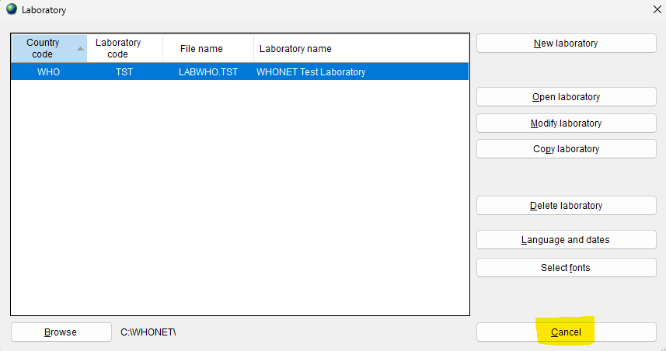

1. Press “File” on the main menu, then select “EARS-Vet” and finally “New laboratory” as shown below.

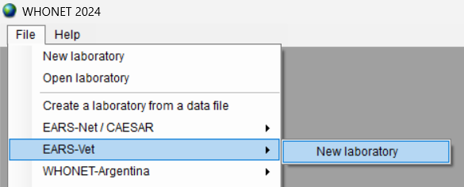

1. Fill in the details for your country, laboratory name and code.
   1. Be sure to select “Human, Animal, Food, Environment” so that the relevant data fields will be added to your configuration.
   2. Press “OK”.

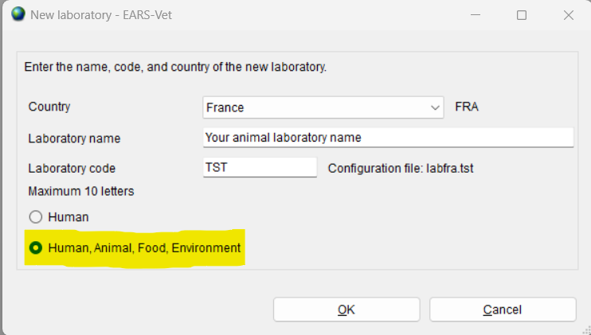

1. The next question will ask you whether you predominantly test using CLSI or EUCAST guidelines. Please choose the most appropriate answer here. Additional antibiotics can be added (from either guideline) after your default configuration has been generated with this process.
2. After confirming your guidelines above, your new configuration will be generated. You will be presented with the option of viewing the details on the next screen. If you need to make modifications, press “Yes”. If not, you may continue to the main WHONET screen by pressing “No”.

#### Create a WHONET configuration for data files processed with the BacLink software

If you have processed your data with the BacLink software, then you can create a corresponding configuration for WHONET by scanning the BacLink output file(s). This will ensure that your configuration details match your database, which may not be precisely the same as the default details included with the “manual” data entry configuration described above this section.

1. Open WHONET and choose “Cancel” on the laboratory configuration screen.
2. Press “File” on the main menu, then select “Create a laboratory from a data file” as shown below.

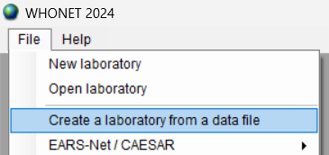

1. Enter the details for your laboratory, then choose one or more existing EARS-Vet data files that you’ve processed with the BacLink software.

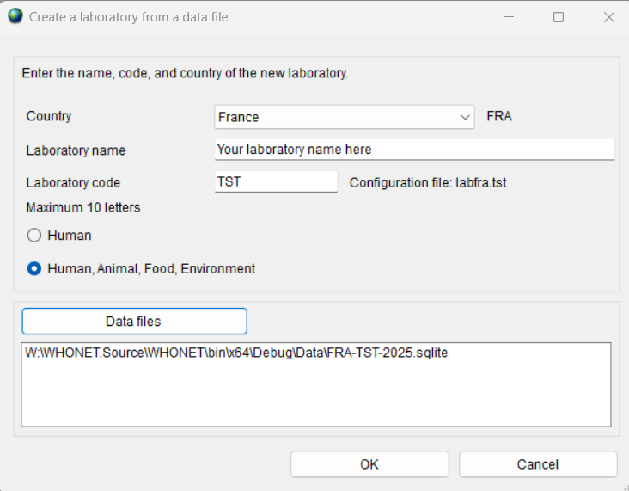

1. The following screen will ask you if you would like to “Generate code lists for the selected fields” shown in a list. You may decline to do this, as these values are only relevant for manual data entry and will have no effect if they are included with this configuration.
2. The system will then analyze the provided data to generate default antibiotic profiles.
3. Finally, you will be presented with an option to view and modify the configuration. You may skip this step if you do not wish to review the configuration at this time.

## Manual data entry

When an LIS or instrument data feed is **not** available, you may use the configuration generated in the relevant section above to enter data using WHONET’s interface. If there is a data feed available with the laboratory results relevant for EARS-Vet, it is highly recommended that you use BacLink to process that data into a WHONET-readable file rather than using the manual data entry procedure described below to avoid duplicative work and to improve reliability.

For more information on BacLink as it relates to EARS-Vet, please review this document. <https://whonet.org/WebDocs/BacLink_EARS-Vet_Data_Import.pdf>

If you are unable to obtain a data feed that can be processed with BacLink, please follow the manual data entry procedure outlined below.

1. Open the EARS-Vet configuration by pressing “File”, “Open laboratory” and choosing the EARS-Vet configuration you have created previously.
2. From the main menu, choose “Data entry”, “New data file”.
3. A data entry screen should appear with questions and code lists corresponding to the EARS-Vet protocol. You may use this screen to enter your data and view the existing isolates in the data file.
   1. Please ensure that the “Origin” selection at the top of the screen is set to “Animal” or “Food” (as appropriate for your isolate), which will cause only the relevant data fields to appear as shown below.

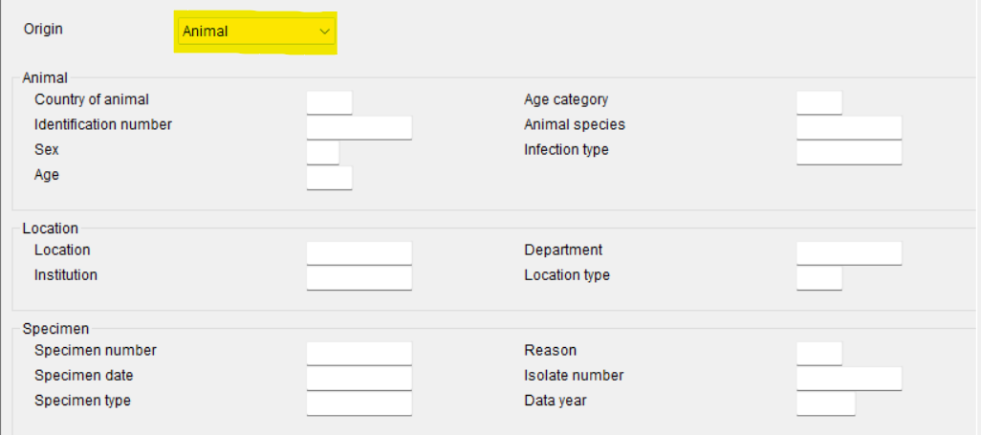

1. For further information on general WHONET data entry, please see the documents found on your computer by pressing “Help”, “Documentation” from the main WHONET menu, or online at the following URL.
   1. <https://whonet.org/WebDocs/WHONET_9.Data_entry_Isolate_entry.pdf>

## How to export data in the EARS-Vet format

These steps are applicable to both manually entered data, as well as data processed with the BacLink software.

1. Using “File”, “Open laboratory”, select the EARS-Vet configuration generated with one of the methods described above.
2. From the main WHONET menu, press “Data entry”, “Combine, export, or encrypt data files”

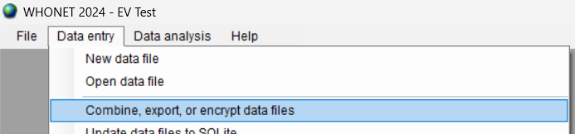

1. Press the “Data files” button and select one or more data files to include in the export.
2. From the “Save as type” menu, choose “EARS-Vet”.

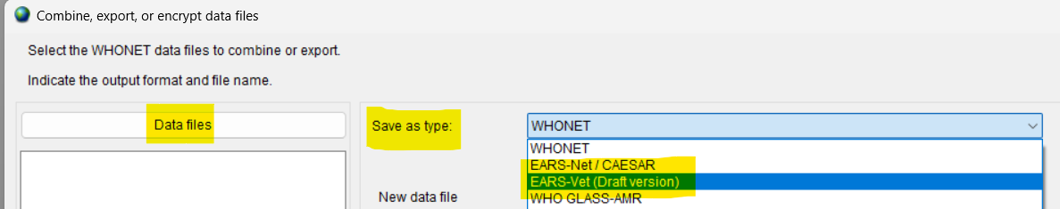

1. When you activate this export, another set of options will appear below as shown.

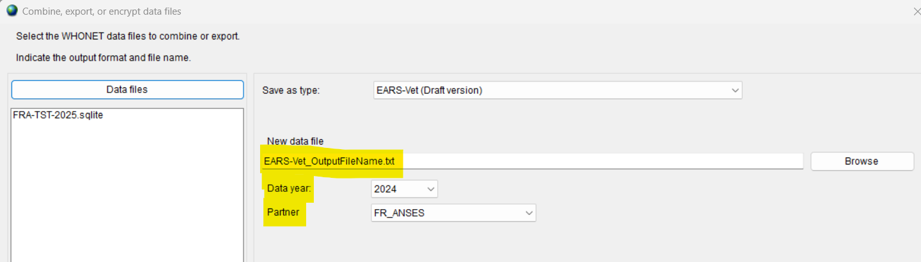

1. Ensure that you have chosen the correct “Data year” and “Partner” values. The “Data year” you select will correspond to the “DATA_YEAR” field in your database file and is used as a selection filter when generating data. Only isolates with a matching data year in your data file will be considered for export to EARS-Vet.
2. Press “Combine” near the bottom of the form. You should receive a message indicating that the conversion was completed successfully.
   1. If instead a message appears indicating that no results were found, the most likely reason for this is that the data files you’ve selected are missing values for DATA_YEAR.
   2. You must correct this deficiency in the data files and repeat the EARS-Vet export.
3. The output file will be in the “C:\WHONET\Data\” folder on your computer by default and will be named according to the value provided in the “New data file” text box on the “Combine, export, or encrypt data files” form.
   1. This output file is ready to be uploaded to the EARS-Vet platform.