BacLink – InFARM Data Import



WHO Collaborating Centre for Surveillance of Antimicrobial Resistance

Boston, July 2024

Table of Contents

Background 2

About this document 2

How to create a new InFARM-specific BacLink configuration 2

Creating a BacLink configuration for data sources other than the FAO InFARM template 4

Setting fixed values for key InFARM data fields 12

Importing InFARM data files with BacLink 14

## Background

InFARM stands for the “International FAO Antimicrobial Resistance Monitoring System”. More information can be found at the following URL:  
<https://www.fao.org/antimicrobial-resistance/resources/database/infarm/en/>

The InFARM protocol is subdivided into two categories: Model A (isolate-level data) and Model B (aggregate statistics). Countries can choose between submitting more granular data with Model A or aggregate statistics with Model B. Countries make these determinations using the InFARM web portal, and then use the corresponding settings in WHONET to generate the data files for upload to the portal.

## About this document

This document provides information on how to import data from one of two sources into a WHONET data file compatible with the FAO InFARM data export feature.

If your data are presently stored in an FAO InFARM Excel or text file template, you will follow the procedures for “How to create a new InFARM-specific BacLink configuration”. The details of this format are fixed, so BacLink does not require additional configuration for these files.

Alternatively, if you have a different data source exported from an LIS or laboratory instrument you will follow a different procedure for creating your configuration. Because the details of your data files are not known, you must follow the standard BacLink configuration procedures, with an additional step to include the InFARM data fields.

Once your configuration file has been prepared, you will follow the procedure for processing your data files.

## How to create a new InFARM-specific BacLink configuration

To import existing data stored in the FAO InFARM Model A format, you first need to create the corresponding BacLink configuration file.

1. From the main screen of BacLink, press the “New format” button highlighted below.

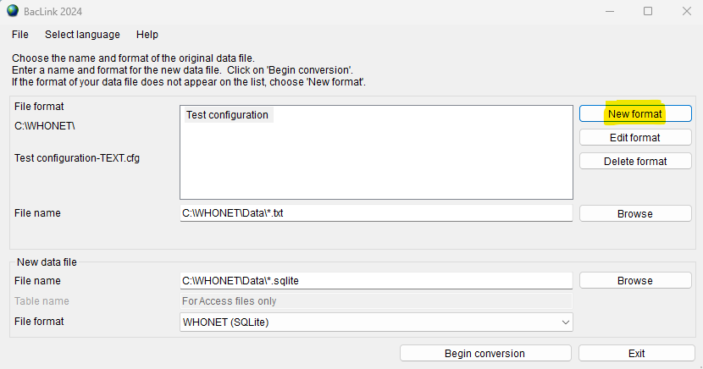

1. Fill in the first three questions regarding your country, laboratory description, and laboratory code.
2. Press the “File structure” button and select either “InFARM (Excel)” or “InFARM (Text)” from the list of options depending on the type of existing data files you have.
   1. If you have a mixture of both types (Excel and CSV), then you will need to create one configuration for each type.

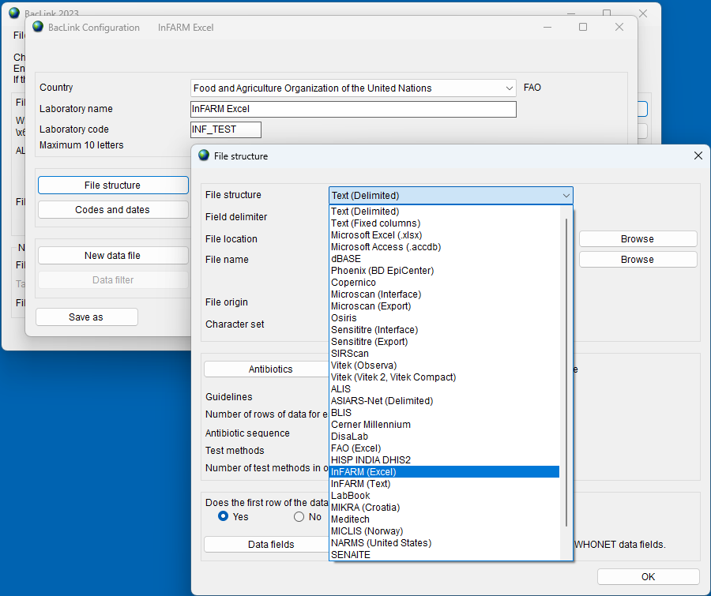

1. Press “OK” on the “File structure” screen to return to the “BacLink Configuration” screen.
2. Press “Save” on this screen and return to the main menu, where your new configuration file should be listed.

## Creating a BacLink configuration for data sources other than the FAO InFARM template

This section guides the user through creating a configuration that is compatible with the InFARM protocol when you have data files available from an LIS, laboratory instrument, or other data source (not including the FAO InFARM Excel or text templates covered above). Because your data may be stored in any format presently, specific instructions for your situation will vary from the procedure below.

Comprehensive guides for BacLink configuration can be found on our website here: <https://whonet.org/training.html#bacLinkResources>

The key point as it relates to InFARM is that you must match your data fields to those in the InFARM protocol. Regardless of the data file structure you have, you will modify the list of fields and include all the InFARM data fields with your configuration. Once the InFARM data fields are added to your configuration, you can then choose a sample data file through the BacLink interface and match your data fields to the InFARM data fields.

The choice of the “File structure” will dictate the initial settings BacLink uses, which must be supplemented with the InFARM data fields as mentioned above.

1. From the main BacLink screen, press “New format”.
2. Answer the three questions near the top for “Country”, “Laboratory name” and “Laboratory code”.
3. Press the “File structure” button.
   1. The first question on the form which appears is for “File structure”.
      1. If your data comes from an interface that we have on our list, you may use that to preconfigure much of the data feed. Skip to step 4.
      2. If your file structure is not included on the list of options, you will need to configure the system yourself by choosing “Text (Delimited)” or “Excel” as appropriate.
         1. “Text (Delimited)” files are text files where a known character is used to separate the data values, such as a comma or TAB character. When this file structure is required, please ensure that the correct “Field delimiter” selection is made on the list below the “File structure”.
         2. With either generic format, you must also answer the questions on the “Antibiotics” form accurately. Press the “Antibiotics” button to view these questions. Please see the general BacLink documentation for assistance with this subject.
         3. Press “OK” when you are finished with configuring the antibiotics.

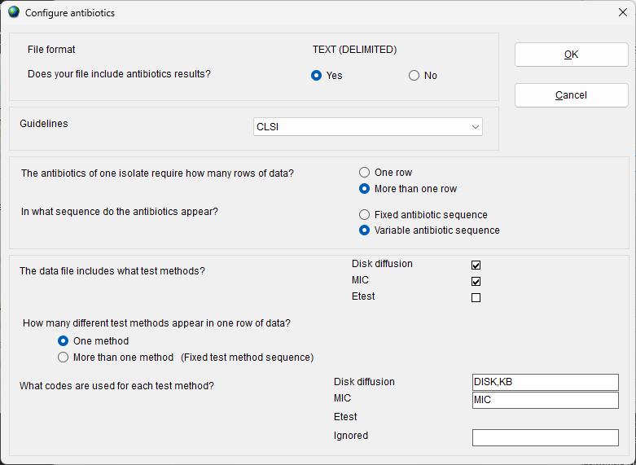

1. You will now add the data fields relevant for the InFARM protocol.
   1. Press the “Data fields” button near the bottom of the “File structure” form as shown below.

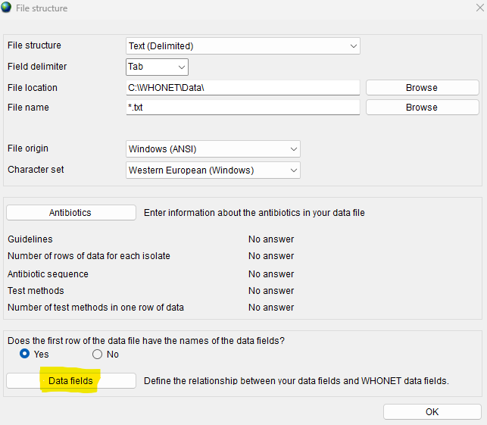

* 1. Below the list of data fields on the left, press the “Modify the list of data fields” button.
  2. Press the “Modify list” button on the subsequent form.

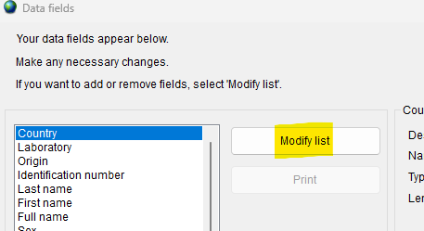

* 1. Choose “FAO – InFARM” from the list of available “Data categories” as shown below.
     1. This will display all InFARM data fields below the “Data categories” list.

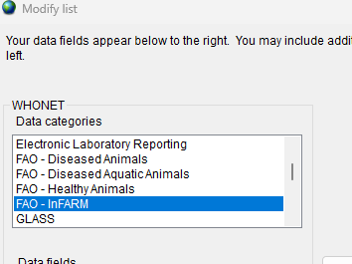

* 1. Click the “Country” field to highlight it.
  2. Scroll to the bottom of the “Data fields” list.
  3. Press and hold the “Shift” key on your keyboard while you click on the last data field on the list.
     1. This should select every item on the list except for the special “User-defined” option at the very top of the list.

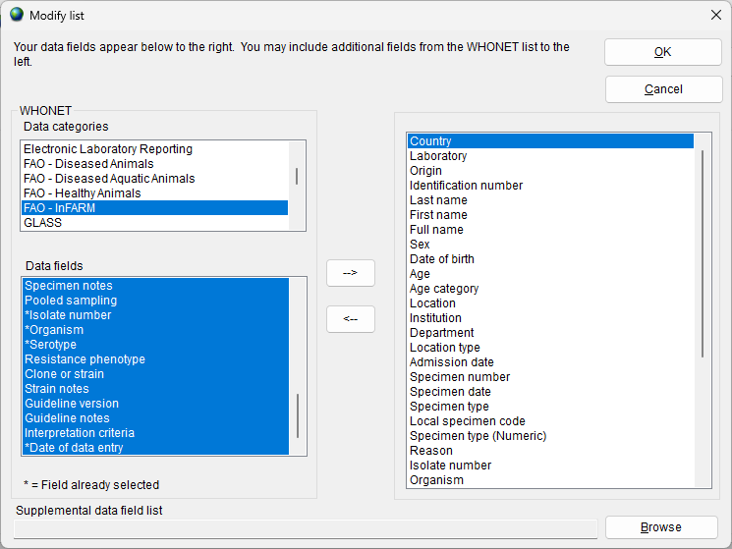

* 1. With every InFARM data field selected as shown above, press the on the left, press the button highlighted in yellow below to add these data fields to the configuration.

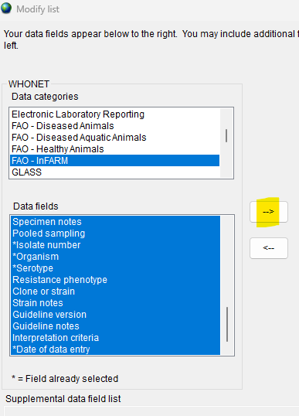

* 1. You will receive a message indicating that some of the data fields were already selected. Press OK.
  2. Any InFARM data fields that were previously missing from your configuration should now be visible near the bottom of the field list on the right.
  3. Press OK to close this form.
  4. Press OK on the next form to return to the screen shown below.

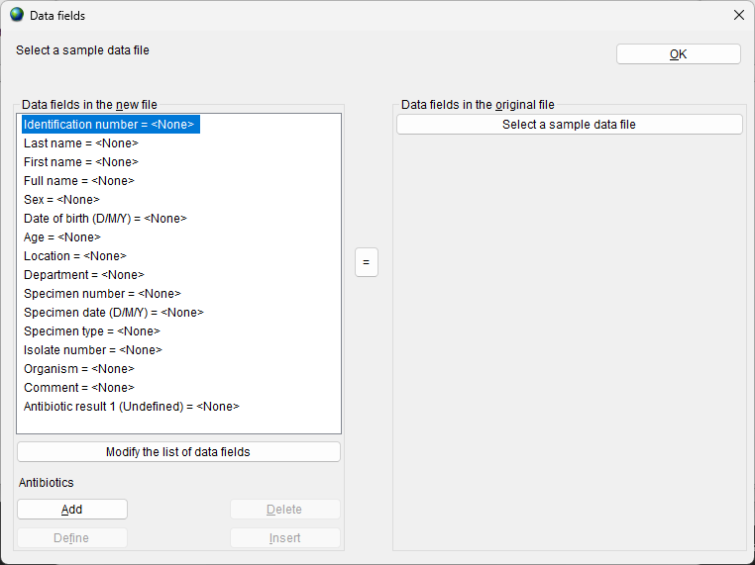

1. Now that the InFARM data fields have been added to your configuration, you need to match as many as you can with the fields in your data file.
   1. Press the “Select a sample data file” button shown in the upper right of the image above.
   2. Choose one of your data files with the “Open file” dialog.
   3. Your data file’s headers should be displayed similarly to what is shown below.

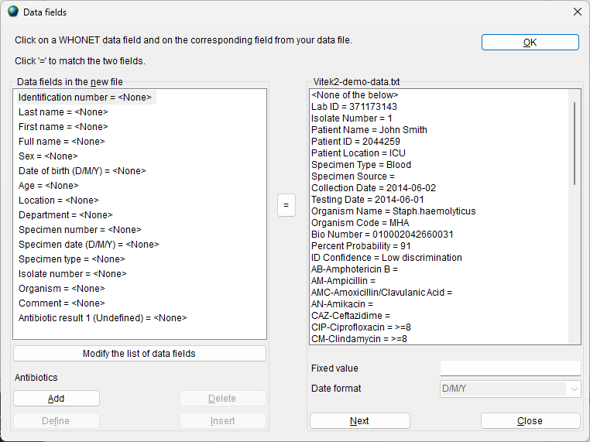

* 1. Use this form to link the data fields in the configuration with those in the data file. Please see the standard BacLink documentation for more information about this subject, as well as how to correctly configure your antibiotics which depends upon the file structure of your input data.
  2. When you have finished matching your data fields, you may press “OK” near the top of the form to proceed.
  3. Press “OK” on the “File structure” form to return to the laboratory configuration form.
  4. Press “Save” and specify a file name for the new configuration you have created.
  5. After saving the configuration, you may press “Exit” to return to the main BacLink form.

## Setting fixed values for key InFARM data fields

Three of the InFARM data fields should have “fixed” values set for them: “Data year”, “Data representativeness”, and “Surveillance program”. If your data files have any of these three fields, you can match them using the procedure above, and skip this section. More commonly, you will not have fields in your input data for these, and should set them to fixed values as shown in the following procedure.

1. From the main BacLink interface, select your InFARM configuration, and press the “Edit configuration” button on the right.
2. Press the “File structure” button.
3. Press the “Data fields” button near the bottom of the form.
4. Press the “Select a sample data file” button and open one of your data files.
5. Locate and click on the “Data year” field on the left list.
6. Near the bottom right of the form, enter the four-digit year that should be used for categorizing the isolates in your data file. E.g. 2024.
7. Press the “equals” sign in the center of the screen to set the “Data year” field to the fixed value you have specified.

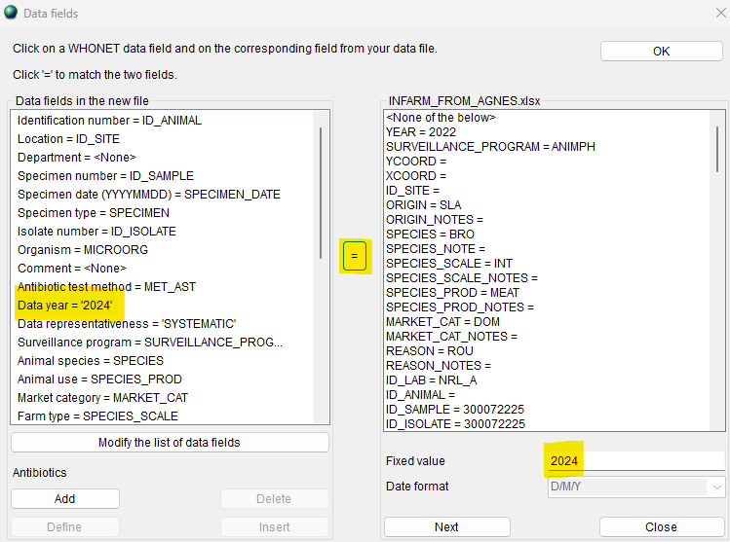

1. Click the “Data representativeness” field on the left list.
2. Enter a fixed value which corresponds to your data from the following acceptable InFARM codes: “PILOTLOC” for local pilot surveillance, “PILOTNAT” for national pilot surveillance, or “SYSTEMATIC” for regular systematic surveillance.
3. Press the “equals” sign in the center of the screen to set the “Data representativeness” field to your chosen value.
4. Click the “Surveillance program” field on the left list.
5. Enter a fixed value which corresponds to your data from the following acceptable InFARM codes.
   1. “ANIMPH” for healthy terrestrial animals and their environment.
   2. “AQUAPH” for healthy aquatic animals and their environment.
   3. “FOODPH” for food commodities, for public health purposes.
   4. “ANIMAH” for diseased terrestrial animals.
   5. “AQUAAH” for diseased aquatic animals.
6. Press the equals sign in the center of the screen to set the “Surveillance program” to the fixed value you have entered.
7. Press “OK” to close the “Data fields” form.
8. Press “OK” to close the “File structure” form and return to the configuration screen.
9. Save the configuration and press “Exit”.

## Importing InFARM data files with BacLink

The procedures above for generating your BacLink configuration must only be performed once on your system. Once you have an InFARM configuration, you can simply select it from the list, choose your corresponding data file, and convert the data into the WHONET data file structure using the procedure below in a few clicks. While the configuration process can be tedious due to the number of details that must be managed, the data export process is very simple. After you have successfully created a configuration for your data files, this is the only section that you will need to repeat on an ongoing basis (unless your files or other details change).

You will follow this procedure whether you have an InFARM-specific (Excel or text) configuration, or whether you have created your own configuration for a different file structure.

1. Choose your InFARM configuration file from the list of options on the BacLink main screen (created using one of the options described in the earlier sections of this document).

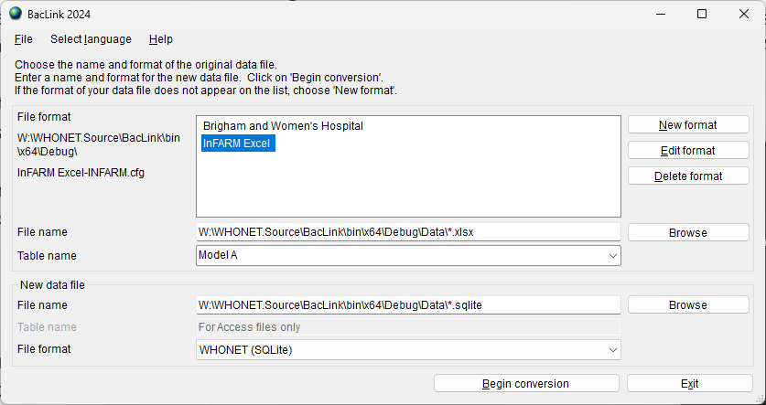

1. Press the “Browse” button associated with the file name, highlighted in the image below.

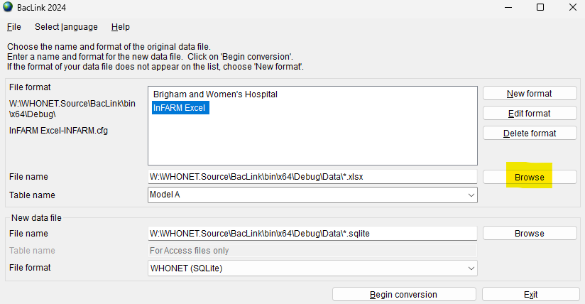

1. Choose your input data file. If you have an Excel configuration, this must be an .xlsx file. If you have a Text configuration, the file should have a .csv or .txt file extension. If you have another file structure, the details for the file name will depend upon that.
2. A default output file name will be provided in the “new data file” section once you select your data file above. You may choose another name or location for the output data or accept the default and move on.

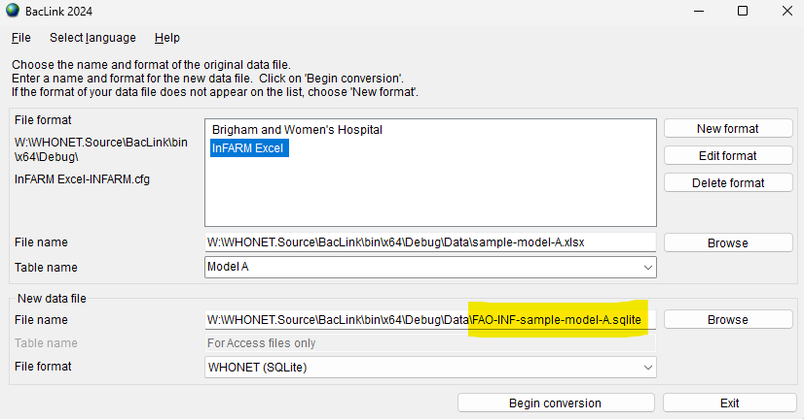

1. Press “Begin conversion” near the bottom of the form.
2. The first three isolates will be shown sequentially so that you can make a brief visual inspection. Some fields will be translated into the WHONET code set, others will be copied as-is. The system should also recognize your antibiotics, which are shown in the lower window.
   1. After reviewing each isolate, press “Next” to continue processing the data file.

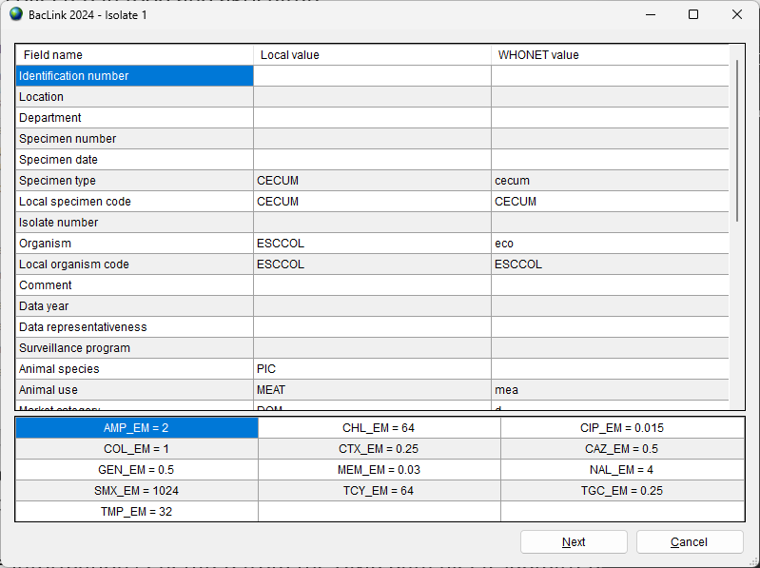

1. For each isolate, press “Next” once you have finished looking over the record.
2. After the third isolate, the entire data file will be processed. You can monitor the conversion on the following progress screen. Newly discovered codes will appear, as well as any conversion problems, such as dates with unrecognized formats, etc.

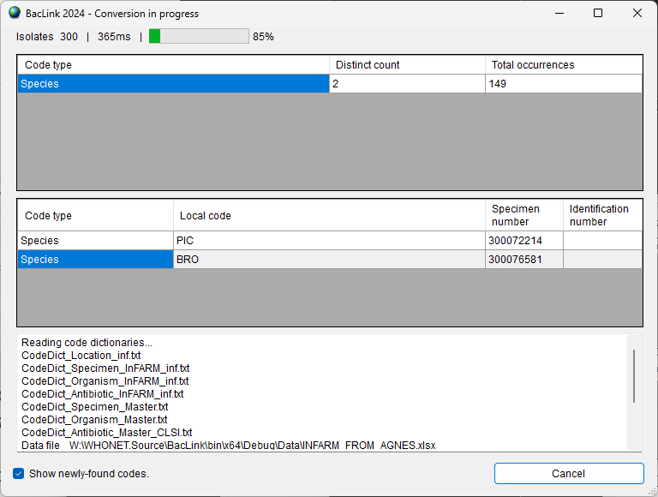

1. Once the conversion has completed, you will be presented with a dialog box allowing you to either continue back to the BacLink main screen, or you can view the entire database’s contents if you choose “View database”.
   1. If there are undefined codes, please follow the standard BacLink documentation regarding code mapping found on the training page of our website below.
   2. If one of the date fields was incorrectly formatted, you can change this in the “Data fields” configuration area. This is also covered in the standard BacLink documentation.
2. After you have defined new codes or made modifications to the configuration you should rerun the BacLink conversion again using the new details. Once the data appears correct, and no further changes are required, you may use the data files generated by BacLink with WHONET analyses and the InFARM exports.
3. For general BacLink questions not covered in this document, please refer to the documentation found on your computer at C:\WHONET\Documents\ or online at the following URL:
   1. <https://whonet.org/training.html#bacLinkResources>