BacLink –

EARS-Vet Data Import



WHO Collaborating Centre for Surveillance of Antimicrobial Resistance

Boston, January 2025

Table of Contents

Background 2

About this document 2

Obtain a sample data file from your existing data source 2

How to create a new EARS-Vet-specific BacLink configuration 2

Importing data files with BacLink 6

## Background

EARS-Vet stands for the “European Antimicrobial Resistance Surveillance Network in Veterinary Medicine”. WHONET can assist users with exporting their AMR data to the EARS-Vet file format, which can be uploaded to their data collection platform. For more information on EARS-Vet, please see the following URL: <https://anses.hal.science/anses-04685234v1/document>

## About this document

This document provides information on how to import data from an existing electronic data source into the WHONET data structure compatible with exportation to the EARS-Vet file format.

## Obtain a sample data file from your existing data source

Please follow the guidance in the section “BacLink – Exporting data from desktop applications, laboratory instruments, and laboratory information systems” found near the bottom of the following support page. <https://whonet.org/training.html>

The steps will be different depending on the type of information system your facility uses, but the goal is to generate a file which can be subsequently processed with the BacLink software.

## How to create a new EARS-Vet-specific BacLink configuration

To import existing data stored in an export from your LIS, laboratory instrument, or other electronic data source, you first need to create the corresponding BacLink configuration file tailored for EARS-Vet.

1. From the main screen of BacLink, press the “New format” button highlighted below.

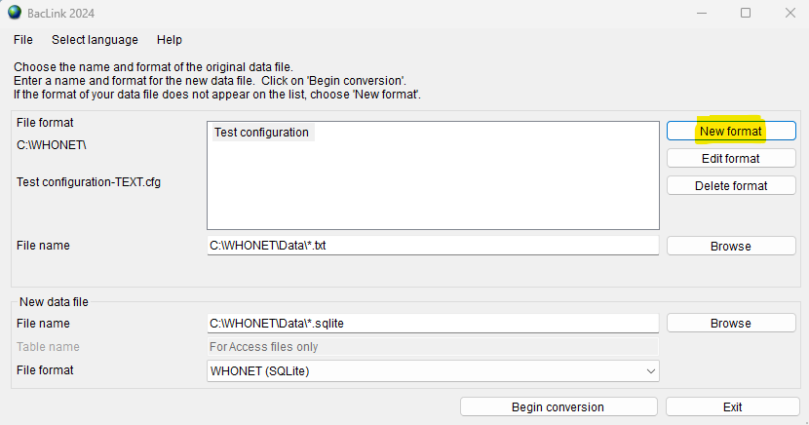

1. Fill in the first three questions regarding your country, laboratory description, and laboratory code.
2. Press the “File structure” button and select from the list of options depending on the type of existing data files you have.
   1. Please see the “BacLink – Getting started” document at the following URL for more information. <https://whonet.org/WebDocs/BacLink.1_Getting_started_Introduction.pdf>
   2. You may also wish to review the links in the section entitled “BacLink – Exporting data from desktop applications, laboratory instruments, and laboratory information systems” found near the bottom of the following support page. <https://whonet.org/training.html>
   3. You may also need to configure the antibiotics for your data file. Please follow the general guidance available on our support page at the links above for more information.
3. Regardless of the type of data file you have, you must now add the EARS-Vet data fields to your configuration. Press the “Data fields” button near the bottom of the “File structure” form shown below.

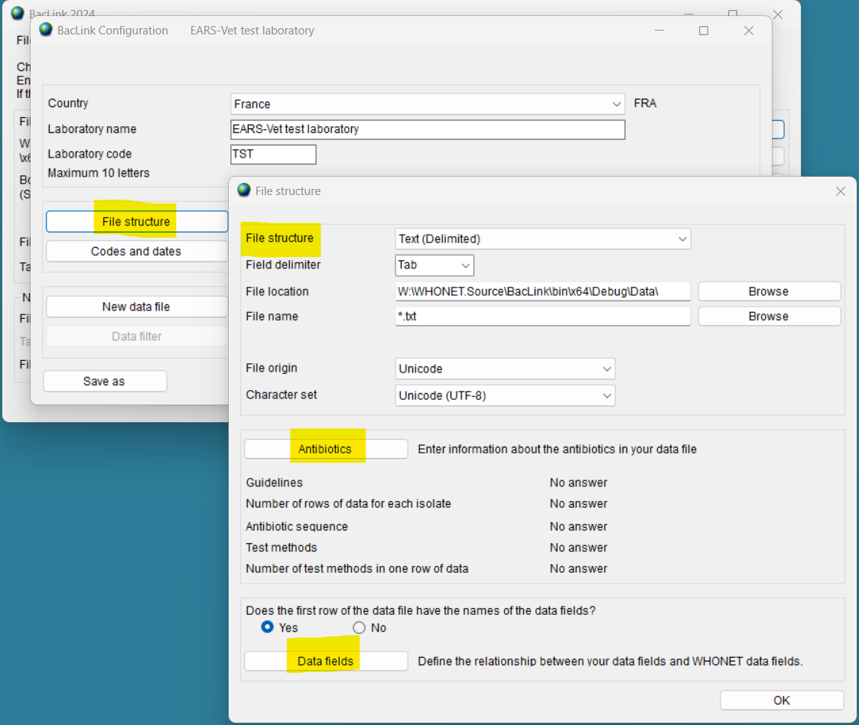

1. Press the “Modify the list of data fields” button.

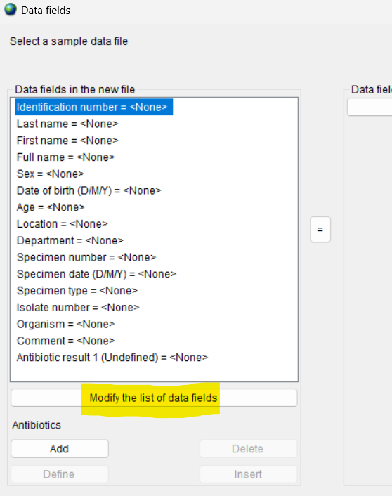

1. On the “Data fields” form which will appear, press the “Modify list” button.

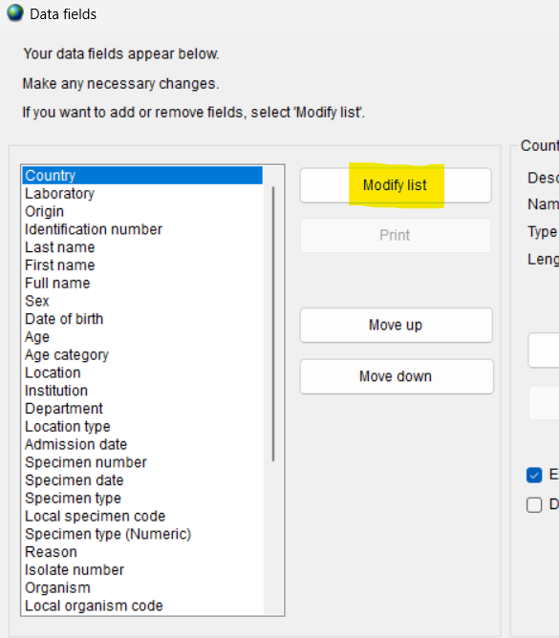

1. Choose “EARS-Vet” from the “Data categories” list and add all the EARS-Vet data fields to your configuration by selecting one or more data fields (using the shift key and your mouse, for example) and pressing the arrow which points to the right.

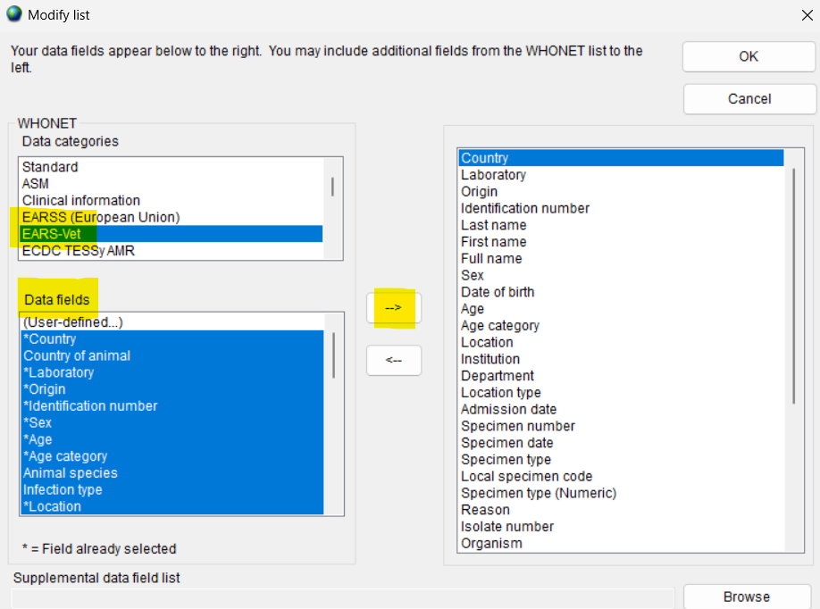

1. The list of data fields shown in the column on the right should now include the EARS-Vet data fields. Press “OK” on the “Modify list” form to return to the “Data fields” form.
2. It is now time to match the data fields in your sample input file with those you’ve just added to your configuration. Begin by pressing the “Select a sample data file” button and choosing your sample AMR data file you’ve extracted previously from your facility’s information system.

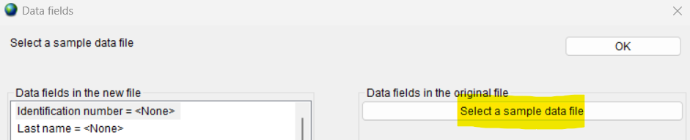

1. After selecting your sample file, BacLink will read the first isolate and display it on the screen along with the data field header names found in your sample file as shown below.
2. You must now match each of your data fields in the left column with the corresponding column shown on the right by highlighting the fields in both columns and pressing the equals sign in the center of the screen.

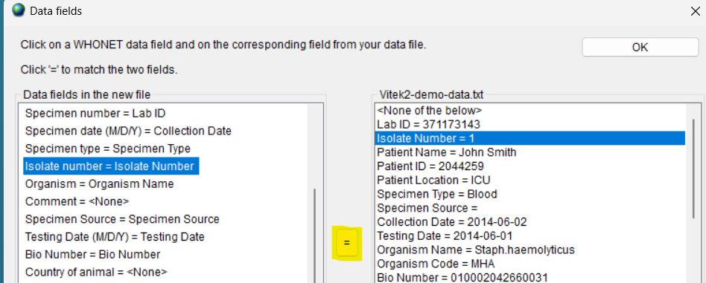

1. Once you have completed your data field matches, you may press “OK” to return to the “File structure” screen.
2. Press “OK” on the “File structure” screen to return to the “BacLink Configuration” screen.
3. Press “Save” on this screen and return to the main menu, where your new configuration file should be listed.

## Importing data files with BacLink

The procedure above for generating your BacLink configuration must only be performed once on your system. Once you have an EARS-Vet configuration, you can simply select it from the list, choose your corresponding data file, and convert the data into the WHONET data file structure using the procedure below in a few clicks. While the configuration process can be tedious due to the number of details that must be managed, the data export process is very simple. After you have successfully created a configuration for your data files, this is the only section of this document that you will need to repeat on an ongoing basis, unless your files or other details change which would necessitate a corresponding change to your configuration.

1. Choose your EARS-Vet configuration file from the list of options on the BacLink main screen.
2. Press the “Browse” button associated with the file name, highlighted in the image below.

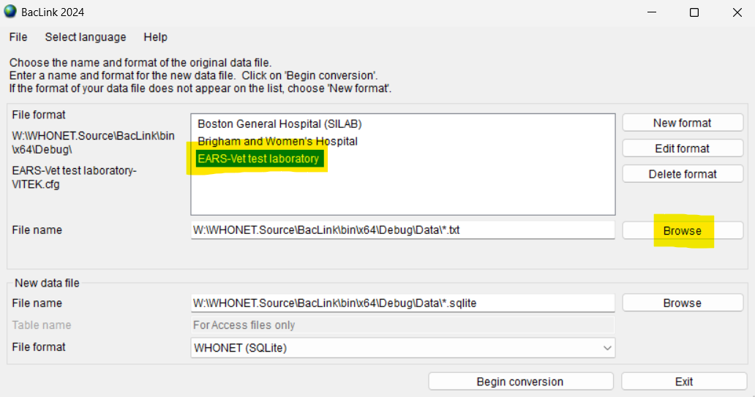

1. Choose your input data file using the file browser, and press OK to select it.
2. A default output file name will be provided in the “new data file” section once you select your data file above. You may choose another name or location for the output data or accept the default and move on.

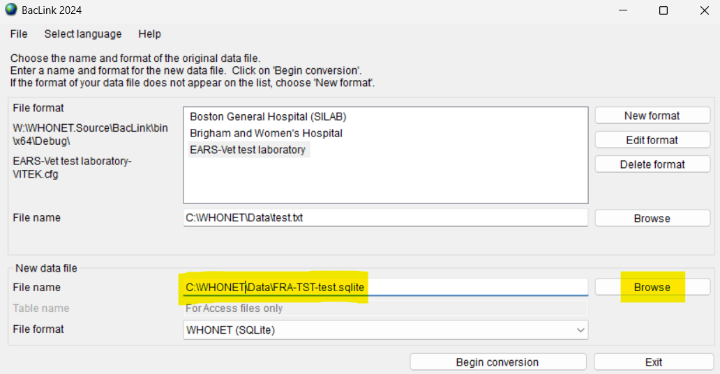

1. Press “Begin conversion” near the bottom of the form.
2. The first three isolates will be shown sequentially so that you can make a brief visual inspection. Some fields will be translated into the WHONET code set, others will be copied as-is. The system should also recognize your antibiotics, which are shown in the lower window. If you do not see antibiotics on this screen, then the system may need to finish processing the file to request that you match these with the known WHONET antibiotics.

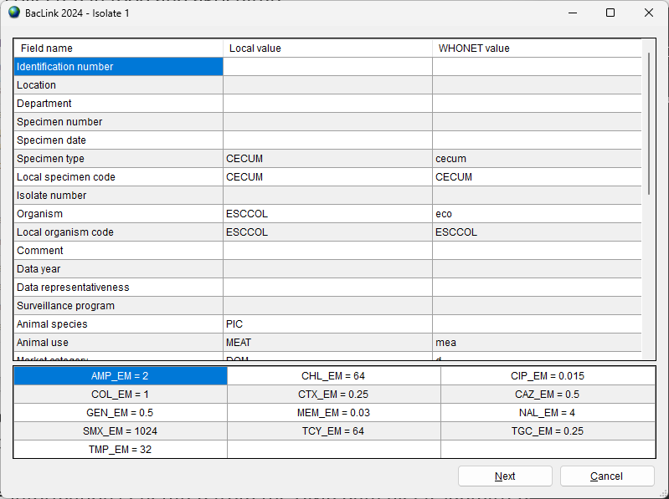

1. For each isolate, press “Next” once you have finished looking over the record.
2. After the third isolate, the remainder of the data file will be processed. You can monitor the conversion on the progress screen. Newly discovered codes will appear, as well as any conversion problems, such as dates with unrecognized formats, etc.
3. Once the conversion has completed, you will be presented with a dialog box allowing you to either continue back to the BacLink main screen, or you can view the entire database’s contents if you choose “View database”.
   1. If there are undefined codes, please follow the standard BacLink documentation regarding code mapping found on the training page of our website.
   2. If one of the date fields was incorrectly formatted, you can change this in the “Data fields” configuration area. This is also covered in the standard BacLink documentation.
4. If you have defined new codes or made any other modifications to the configuration you should rerun the BacLink conversion again using the updated configuration. Once the data appears correct, and no further changes are required, you may use the data files generated by BacLink with WHONET analyses and the EARS-Vet export.
5. For general BacLink questions not covered in this document, please refer to the documentation found on your computer at C:\WHONET\Documents\ or online at the following URL:
   1. <https://whonet.org/training.html#bacLinkResources>