BacLink and SILAB



WHO Collaborating Centre for Surveillance of Antimicrobial Resistance

Boston, October 2024

Table of Contents

Introduction 3

WHONET with SILAB 3

PART 1. Downloading and installing WHONET and BacLink 4

PART 2. Exporting data from SILAB 4

SILAB Instructions 4

PART 3. Configuring BacLink 6

PART 4. Converting SILAB data files to the WHONET data file format with BacLink 9

PART 5. Getting started with WHONET 12

# Introduction

WHONET is Windows-based database software developed for the management of microbiology laboratory data and the analysis of antimicrobial susceptibility test results. The software is available on the WHONET website at the following URL: <https://whonet.org/software.html>

Objectives of the software include:

* Enhancing the local use of laboratory data for guiding therapy, assisting infection control, characterizing resistance epidemiology and identifying laboratory testing errors
* Promoting collaboration in surveillance activities through the exchange of data

WHONET can be used for manual data entry, especially in laboratories without an existing computer system for microbiology data. For laboratories which do have systems for managing their data, the BacLink software is a valuable tool which facilitates the extraction and conversion of data from a number of different sources into WHONET, avoiding the need to re-enter results. BacLink can convert data from many common commercial databases and spreadsheet software, commercial susceptibility test instruments, and hospital and laboratory information systems. BacLink, available free of charge, downloads and installs automatically along with the WHONET software.

# WHONET with SILAB

The purpose of this document is to guide users through the process of exporting identification and antimicrobial susceptibility test (AST) data from the veterinary laboratory information system SILAB developed by the Istituto Zooprofilattico Sperimentale dell'Abruzzo e del Molise Giuseppe Caporale.

The instructions are divided into five parts:

1. Downloading and installing WHONET and BacLink
2. Exporting data from SILAB
3. Configuring BacLink
4. Converting SILAB data files to the WHONET data file format with BacLink
5. Getting started with WHONET

The frequency of data conversions depends on the local data analysis needs and interests. Many laboratories find that a weekly or monthly download is adequate for their infection control and quality assurance purposes, while less frequent analysis may be adequate if the principal use of the data is in following trends in resistance and guiding treatment recommendations.

# PART 1. Downloading and installing WHONET and BacLink

The WHONET and BacLink software are available free-of-charge from the WHONET website: <https://whonet.org/>

Double-click the setup file and select “Run” and follow the installation instructions. This process will install both the WHONET and BacLink software by default into the C:\WHONET\ folder. When you complete the installation, you will see icons for WHONET and BacLink on your desktop. Manuals for both software can be found in C:\WHONET\Documents\ on your computer.

# PART 2. Exporting data from SILAB

SILAB is a laboratory information system (LIS) supporting day-to-day operations in animal health laboratories in many countries in Africa and a few in Asia. Further information can be found in the below two links:

* Home page: [www.izs.it/IZS/Cooperation/IZSAM_and_Africa/SILAB_for_Africa_Project](http://www.izs.it/IZS/Cooperation/IZSAM_and_Africa/SILAB_for_Africa_Project)
* 2019 Publication "SILAB for Africa": An Innovative Information System Supporting the Veterinary African Laboratories, [pubmed.ncbi.nlm.nih.gov/30767711](https://pubmed.ncbi.nlm.nih.gov/30767711)

## SILAB Instructions

* These instructions were made for SILAB version ____ and later. For older versions of SILAB, please contact the WHONET team at [help@whonet.org](mailto:help@whonet.org) and/or IZS.
* Launch the SILAB application and log in to reach the main menu.

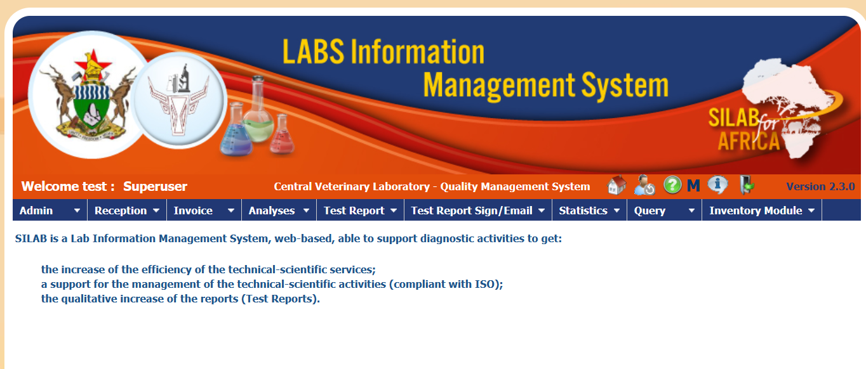

* On the statistics menu, click on “Statistical Data”

* This will bring you to the main data export screen in which you can choose one or more filters.
* The only required filter is for “Date Received”. Enter in the desired time period.

* Choose any additional filters to select the samples and tests that you would like to include in your WHONET files. Common selections by many would be “Sampling purpose” and/or “Sampling plan”.
* To facilitate later data processing, we would generally suggest that you export data within a single year, for example 2024. If your local implementation permits, then you could also try to export results from “Diseased animals” (often “passive surveillance) from “Healthy animals” (often active surveillance).
* At the bottom of the screen, you see three “File types” for the export:
  + “Excel”: This will export aggregate statistics for the selected samples and tests
  + “Full excel report”: This will report results from all tests from all specimens meeting the selection criteria that you have selected, including both culture- and non-culture related tests.
  + “AMR excel report”: This will only export culture and susceptibility test results with a more convenient structure for data import with BacLink. Thus, in general, we would recommend utilizing this data export format:

**Note: at the time of the writing of this tutorial, there are two deficiencies in the AMR Excel Report. If these have not yet been resolved in the most recent version of SILAB, then we would modify the instructions.**

* Click on the “Export” button.
  + **Note: We do not have an image of the full screen above, so we don’t know whether the button is called “Export”.**
* SILAB will then proceed with the data export, creating a new file in your Downloads folder with a predefined name. The first time that you run the expert, the file will be named “FullExcelExport.xls”. With subsequent exports, a number will be added to the file name, such as “FullExcelExport.xls (1)”, “FullExcelExport.xls” (2), *etc*.
  + Note: These are only example file names, you may choose a more appropriate name for your own use.

# PART 3. Configuring BacLink

Start the BacLink program by double-clicking on the BacLink shortcut icon installed on your desktop. The BacLink program screen appears.

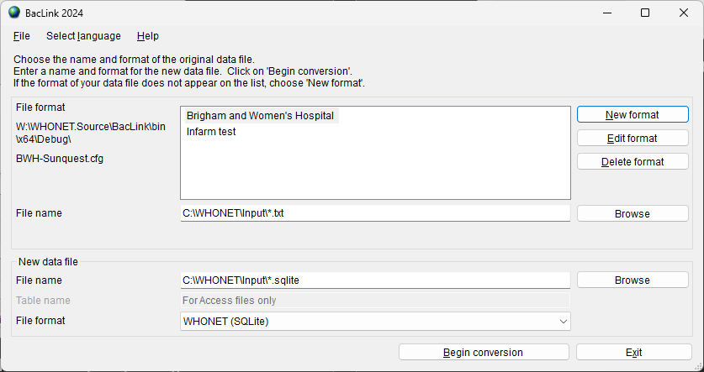

The first time BacLink is used, you must choose the kind of data file you would like to import (SILAB), as well as the name and code for your laboratory. These details are saved in a configuration file on your computer and will be used prospectively each time you need to convert a data file. To create your SILAB configuration, please follow the instructions below.

Click on the **New Format** button. The **BacLink Configuration** screen appears.

From the drop-down box, select the **Country**: for example, *United States*.

Enter the **Laboratory Name** – the name of your laboratory, for example *Boston General Hospital*. If data could be imported from a number of different sources you may wish to indicate this in the laboratory name, for example *Boston General Hospital (SILAB)*.

Enter up to 10 characters for the **Laboratory Code**, for example *BGH*. The laboratory code entered will be used by BacLink and WHONET as the default file extension for your WHONET data files.

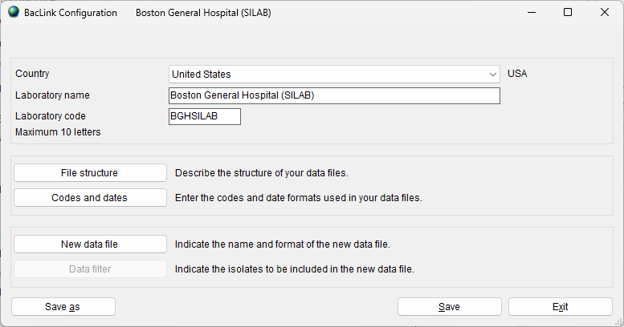

Click on the **File Structure** button, and the screen shown below will appear.

Choose “SILAB” from the “File structure” list at the top of the screen. BacLink will now be configured to accept SILAB data files.

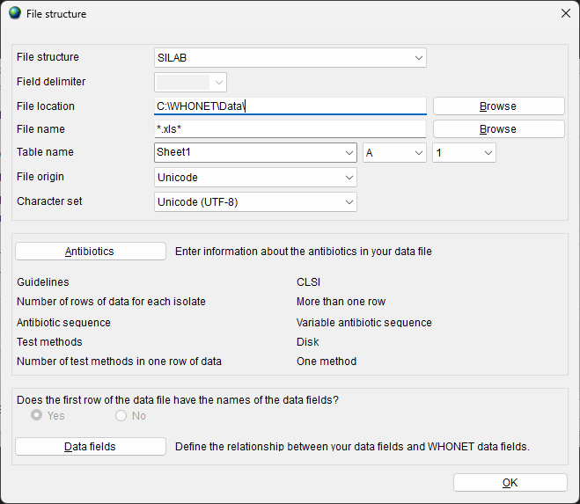

**File Location -** Indicate the folder where the source data (SILAB) files will be stored. C:\WHONET\Data\ is the default location suggested by BacLink, but any convenient location can be used. In many institutions, data files are placed in a folder on a central server or network drive.

Press the “OK” button to return to the “BacLink Configuration” screen.

Optional:

* Though not required, you may wish to click on the **New data file** button on the BacLink Configuration screen. There you can indicate the default data **File location** for your new WHONET files (BacLink’s output files, not to be confused with the source data files you’ve exported from SILAB). You can indicate the name of the WHONET file that you will create, though it is generally more convenient to give a file name later, just before a file conversion, and not here on this screen.
* Click on the **OK** button to return to the BacLink Configuration screen.

Click on **Save** on the BacLink Configuration screen. Give a name to the BacLink configuration file, which will save the above-indicated user selections, for example “BGH-SILAB.cfg”. You may give any valid Windows file name. BacLink will add “.cfg” as a file extension to indicate to BacLink that this is a configuration file.

Click on **Exit** to return to the main BacLink interface. Your newly defined file format will appear on the list of configurations available to you.

# PART 4. Converting SILAB data files to the WHONET data file format with BacLink

Now that you have a BacLink configuration file associated with your SILAB data, you can use BacLink to convert the source data into the WHONET data file format.

From the main BacLink interface, select your newly created configuration file from the central list.

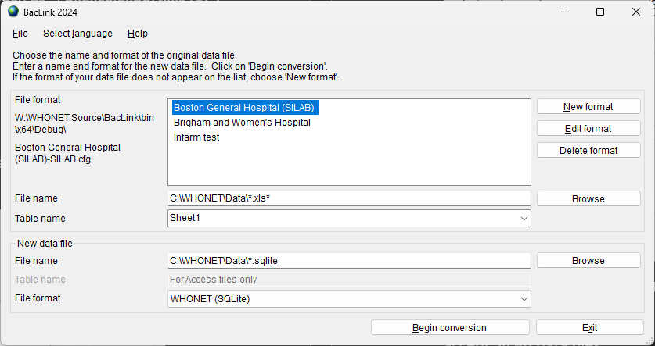

Just below the list of configurations, press the “Browse” button to the right to select a source data file (SILAB export). Ex. C:\WHONET\Data\SILAB_Export_2024-10-17.xlsx

Next, use the lower “Browse” button to provide a new file name for the converted data file. Ex. C:\WHONET\Data\Converted_SILAB_Data_File_2024-10-17.sqlite

Click on **Begin Conversion**. BacLink begins converting the selected SILAB file to a WHONET file. BacLink will display the first three isolates to permit a visual inspection of the accuracy of the conversion. The information from your data file, as read by BacLink, appears to the left of the screen. The information which will be saved in the WHONET file appears to the right of the screen. Where appropriate, WHONET will change your codes and formats to those used by WHONET.

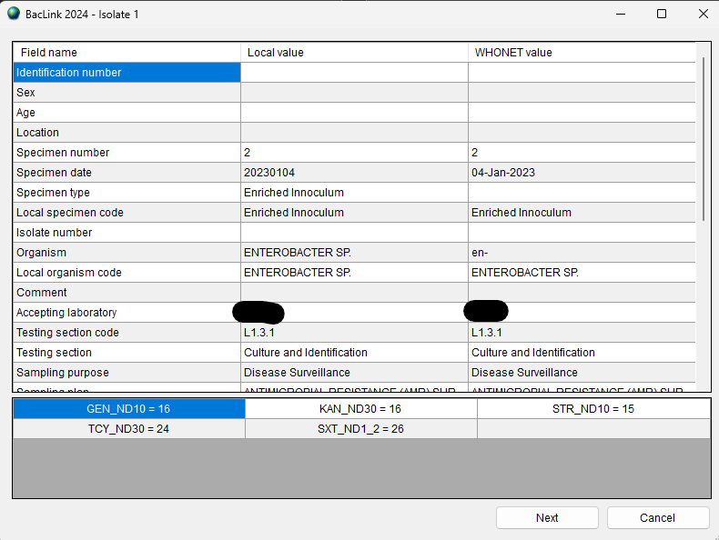

If you notice any discrepancies or errors in the field mappings, you may correct these from the main BacLink screen using “Edit format”.

Click “Next” to advance through the first three isolates. After the third sample isolate, BacLink will then continue until the file is completely converted while displaying a summary of the conversion as shown below.

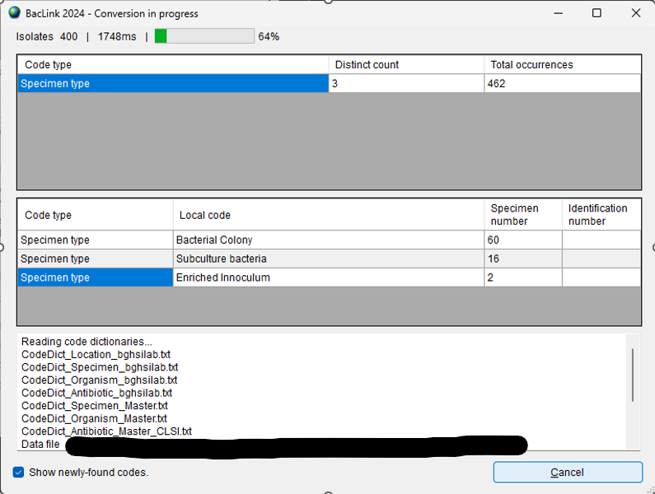

At the end of the conversion, you will be presented with the screen below. You may inspect the data file by pressing “View database” or continue to the next step.

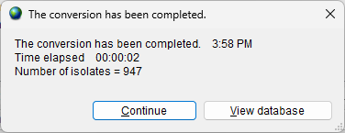

If BacLink does not understand some of the data codes in your file, the program asks whether you would like to define them.

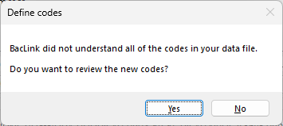

If you answer **Yes**, you will be shown a list of the various organism, antibiotic, specimen type, location, gender, and test result codes that are undefined. Click on a variable of interest, such as “Organism”, and click **Define codes**.

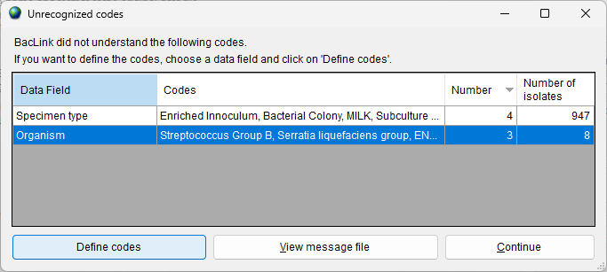

You will subsequently be shown a list of each of the unrecognized codes. Select a code and click **Define code**. For most variables (except Location), you will be asked to select the matching or closest term from a list of WHONET codes.

For Location you will have the option of defining the patient department and type (inpatient, outpatient, ICU, *etc.*). Continue defining codes until you have defined all, or at least the most important and frequent, data elements. When finished click “OK”, then “OK” again to return to the main BacLink interface.

**If you have defined codes, you should then convert the same file a second time to utilize the new code matchings in the converted data file. When finished with BacLink, click Exit.**

# PART 5. Getting started with WHONET

Now that you have created a valid WHONET file using BacLink and your SILAB export file, you can proceed to WHONET. For details on the use of WHONET, consult the manual WHONET and training materials available on <https://whonet.org/training.html>

1. **Creating a laboratory configuration**
   1. To begin using WHONET, you must first create a “Laboratory configuration” with descriptive information about your laboratory – antibiotics, breakpoints, patient locations, etc. For laboratories not using BacLink, this is typically done with a feature called “New laboratory”, which requires you provide all of these details.
      1. We have resources available on the training page of our website which describe this process in detail.
   2. However, for users of BacLink, there is a shortcut available called “Create a laboratory from a data file”, which will glean as much information as possible from the WHONET data files you provide, making configuration much easier.
      1. Double-click the WHONET icon on your desktop or start menu.
      2. You will be shown a list of WHONET laboratories defined on your computer. With the default installation, you will see a single laboratory “WHONET Test Laboratory”.
      3. Press **Cancel** to indicate that you would like to proceed without selecting a laboratory.
      4. From the main WHONET interface, press “**File**” from the main menu, and choose the option to “Create a laboratory from a data file”.
      5. Indicate your country name, laboratory name and code.

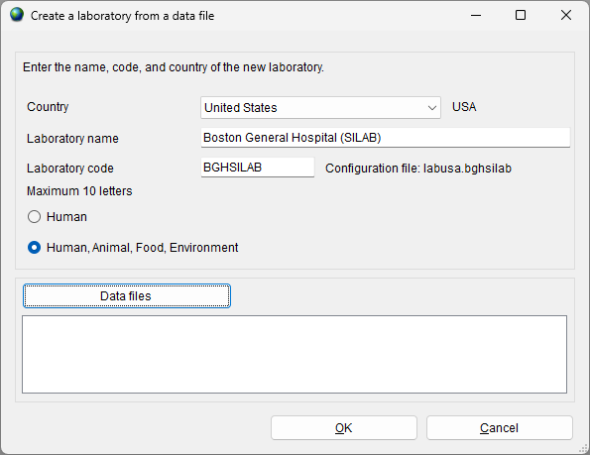

* + 1. Press the “Data files” button to select one or more files to scan and press OK.

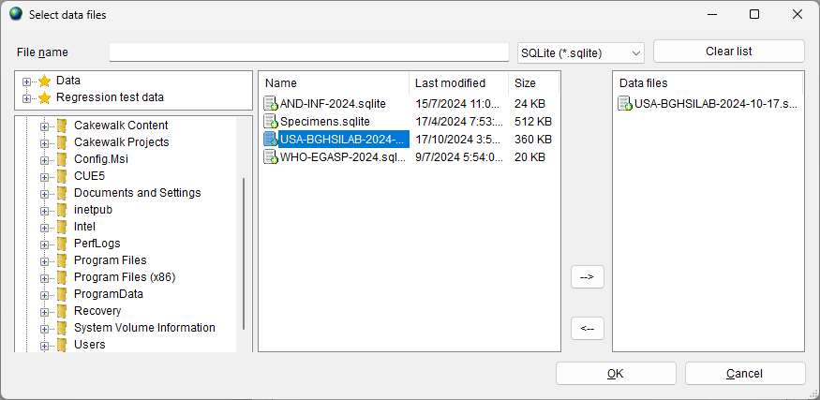

* + 1. Press OK to begin generating your laboratory configuration, following any prompts you see on the screen. WHONET will scan the contents of this file – antibiotics, location codes, *etc.* – and create a valid WHONET laboratory configuration.
    2. When requested, you can click **Yes** if you want to review the details of the configuration. Otherwise, click **No**, and continue with Data analysis.

**Note: After creating the configuration using this method, further edits such as any modifications to the antibiotic breakpoints, can be done with *Modify laboratory*** **which is found on the** ***File*** **menu.**

1. **Using WHONET**
   1. Once you have defined a laboratory configuration, it will appear in the list of laboratories each time you launch WHONET.
   2. Click on your laboratory name and press **Open laboratory** to begin with data entry or data analysis.
   3. Please see the training area of our website for more information about available WHONET analyses.